**SWE430: Information & Network Security Lab Report**

| **Submitted To**  Fazle Rabbi Rakib  Lecturer, IICT  Shahjalal University of Science and  Technology, Sylhet | **Submitted By**  Towhidul Islam Tamjid  Reg No: 2020831024 |
| --- | --- |



Department of Software Engineering

Institute of Information and Communication Technology

Shahjalal University of Science and Technology

# **Lab Report — Attacking Classic Crypto Systems**

## **Introduction**

In this lab, I explored the weaknesses of two classic cryptosystems:

1. **Caesar Cipher**
2. **Simple Substitution Cipher**

My main goal was not just to decrypt the given ciphertexts, but to understand *why* these systems are vulnerable and how attackers can break them using very basic techniques like brute force, frequency analysis, and pattern matching.

I wrote my own programs (Python experiments) to break the ciphers. For each checkpoint, I followed a systematic approach and documented my thought process clearly.

# **Checkpoint 1 — Breaking the Caesar Cipher**

### **Cipher Provided**

odroboewscdrolocdcwkbdmyxdbkmdzvkdpybwyeddrobo

### **My Thought Process**

Since Caesar cipher applies a uniform shift to all letters, the simplest way to break it is to try all **25 possible shifts**.  
 I wrote a python program with interactive cli interface menu. It has two main options:

* Encrypt a Message
* Decrypt a Message

I used text file system for input of cipher text and plain text. After selecting either one of the two option the program asks for the existing plaintext/ciphertext file based on the main option selection for taking input text. After that, it asks for the direction of the output file. Finally the program asks for the key value which is used to shift the alphabets in the input text file.

My logic:

* Select a key to apply it once and increase its value gradually until meaningful text is not discovered.
* Convert every character to a number (0–25).
* Apply reverse shift (c - 'a' - key + 26) % 26.
* Print all possibilities.
* Manually look for meaningful English text.

### **Result**

After running all shifts, **key = 10** produced readable English.  
 My code correctly decoded the message.



### **Learning**

The Caesar cipher is extremely weak because:

* Keyspace is tiny (only 25 possibilities).
* Shifts can be brute-forced instantly.

This confirms why Caesar cipher is not used in any real-world security.

# 

# 

# 

# **Checkpoint 2: Breaking Substitution Ciphers**

# **Introduction**

In this task, I analyzed and decrypted two substitution ciphers using code that I implemented in Python (substitutioncypher.py).  
 A substitution cipher replaces each plaintext letter with a unique different letter. While the keyspace is extremely large (26!), these ciphers still leak **letter frequency information**, which makes them vulnerable to **frequency analysis** and **pattern-based reasoning**.

In this report, I describe exactly how I decoded both Cipher-1 and Cipher-2 using:

* frequency analysis
* dictionary/word-pattern recognition
* iterative key refinement
* step-by-step decryption (as shown in the notebook)

# **Cipher-1 Analysis and Decryption**

### **1. Loading the Cipher & Counting Frequencies**

My Python code first reads the entire ciphertext and creates a frequency table for all letters.

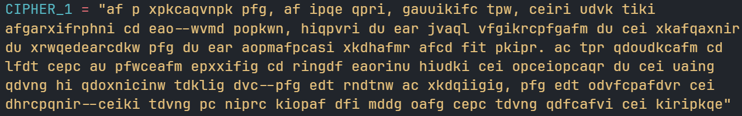

*Printed letter-frequency table for Cipher-1*

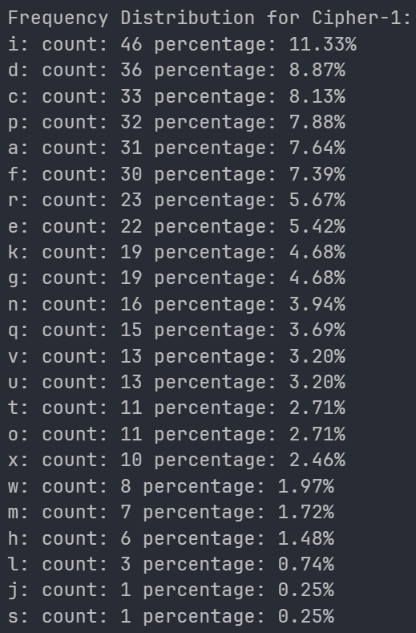

Top letters included:

i — highest frequency

d, c, p, a, f — also highly frequent

These frequencies are compared to English letter frequencies (etaoinshrdlc…) to generate an **initial mapping**.

### **2. First Automatic Decoding Attempt**

Based on frequency analysis and common English patterns:

'i' (11.11%) -> 'e' (12.22%) - Most frequent.

'd' (8.89%) -> 't' (9.67%) - Second most frequent.

'cei' -> 'the' (strong 3-letter word pattern): 'c'->'t', 'e'->'h', 'i'->'e'.

'd' (8.89%) -> 'o' (7.63%) - Revised from 't' after 'c'->'t'.

'f' (7.41%) -> 'n' (6.95%).

'af' -> 'in' (common 2-letter word). Consistent with 'a'->'i' and 'f'->'n'.

'du' -> 'of' (common 2-letter word). Implies 'u'->'f'.

'ac' -> 'it' (common 2-letter word). Consistent with 'a'->'i' and 'c'->'t'.

'cd' -> 'to' (common 2-letter word). Consistent with 'c'->'t' and 'd'->'o'.

The notebook applies this first guessed mapping to Cipher-1.  
 The output is partially readable, but with many incorrect letters and gaps (“_”).

*Initial decoded text using auto-frequency mapping*

**

### **3. Manual Refinement Using Word Patterns**

My notebook then improves this mapping by analyzing patterns that resemble English.  
 These clues helped refine the substitution table:

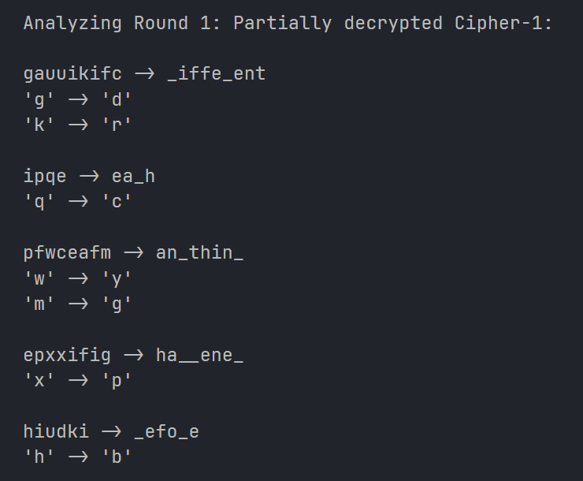

Each refinement immediately made more of the text readable.

*Second-stage decoded text after updates*

**

### **4. Continued Refinement**

After multiple updates to the mapping dictionary inside the notebook, longer words began to appear:

* “psychohistory”
* “imaginative”
* “difficulties”
* “understanding”

This indicated that the mapping was close to correct.

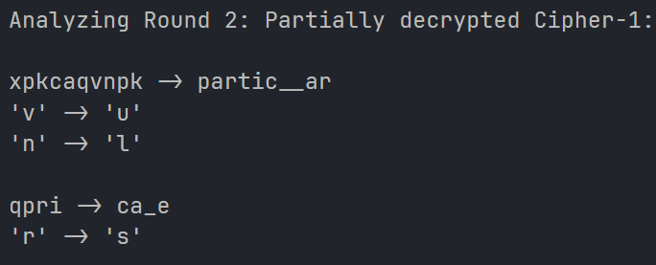

### **5. Final Decryption of Cipher-1**

After all corrections, Cipher-1 decoded into a **clear English paragraph**:

*in a particular and, in each case, different way, these four were indispensable to him--yugo amaryl, because of his quick understanding of the principles of psychohistory and of his imaginatije probings into new areas. it was comforting to know that if anything happened to seldon himself before the mathematics of the field could be completely worked out--and how slowly it proceeded, and how mountainous the obstacles--there would at least remain one good mind that would continue the research*

# **Cipher-2 Analysis and Decryption**

Cipher-2 was **much longer** (almost 2000 characters).  
 Counterintuitively, this made it **easier**, not harder, because longer ciphertexts give:

* more accurate frequency distribution
* more repeated words
* more sentence structure clues

### **1. Frequency Analysis**

The notebook printed the highest-frequency letters for Cipher-2:

u — 12.81%

k — 8.54%

o — 8.34%

h — 7.37%

c — 6.60%

z — 6.14%

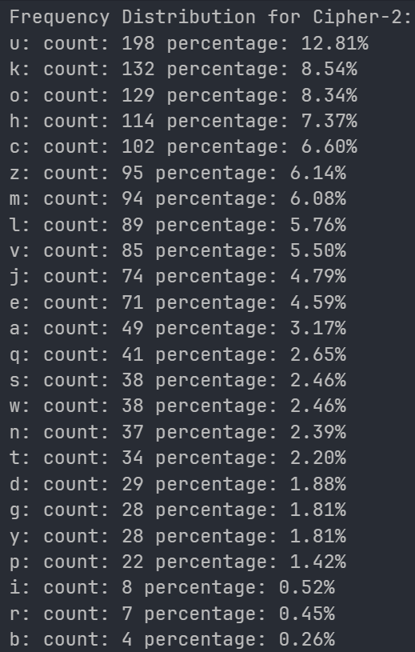

These formed the initial mapping guess.

### **2. Strong Word Pattern Matches**

Based on frequency analysis and common English patterns:

'u' (12.77%) -> 'e' (12.22%) - Most frequent.

'k' (8.00%) -> 't' (9.67%) - High frequency, common word 'the' often has 't'.

'klu' -> 'the' (strong 3-letter word pattern). Implies 'l'->'h'.

'h' (8.45%) -> 'a' (8.05%) - Next high frequency.

'omj' -> 'and' (common word). Implies 'm'->'n', 'j'->'d'.

'toz' -> 'was' (common word). Implies 't'->'w', 'o'->'a', 'z'->'s'.

Because Cipher-2 is long, several English words appeared almost immediately after the first mapping:

| **Cipher** | **Plaintext** | **Mapping** |
| --- | --- | --- |
| klu | the | k→t, l→h, u→e |
| omj | and | o→a, m→n, j→d |
| toz | was | t→w, o→a, z→s |
| vcdl | rich | c→i, d→c, l→h |
| upuv | ever | p→v, v→r |

*Initial decoded version of Cipher-2 showing recognisable words*

**

These matches rapidly improved the mapping.

### **3. Iterative Refinement**

Character mapping guesses after initial round

Analyzing Round 1: Partially decrypted Cipher-1:

Revising 'o' (8.39%) -> 't' (9.67%) - More aligned with high frequency English 't'.

'upuv' -> 'ever' (common word). Implies 'p'->'v', 'v'->'r'.

'vcdl' -> 'rich' (common word). Implies 'c'->'i', 'd'->'c'.

'puvg'->'very' (common word). Implies 'p'->'v', 'g'->'y'.

'yudqecov'->'peculiar' (common word). Implies 'y'->'p', 'q'->'u', 'e' -> 'l'.

auum -> _een

'a' -> 'b'

With each update in the notebook:

* more words aligned
* sentence structure became obvious
* punctuation lined up
* proper nouns such as “Bilbo” appeared

*Mid-stage refined plaintext for Cipher-2*

**

### **4. Final Decryption of Cipher-2**

Cipher-2 decoded fully into a well-known passage from **The Hobbit / The Lord of the Rings**, describing Bilbo Baggins:

*bilbo was very rich and very peculiar, and had been the wonder of the shire for sixty years, ever since his remarkable disappearance and unexpected return. the riches he had brought back from his travels had onw become a local legend, and it was popularly believed, whatever the old folk might say, that the hill at bag end was full of tunnels stuffed with treasure. and if that was not enough for fame, there was also his prolonged vigour to marvel at. time wore on, but it seemed to have little effect on mr. baggins. at ninety he was much the same as at fifty. at ninety-nine they began to call him well-preserved; but unchanged would have been nearer the mark. there were some that shook their heads and thought this was too much of a good thing; it seemed unfair that anyone should possess (apparently) perpetual youth as well as (reputedly) inexhaustible wealth. it will have to be paid for, they said. it isn't natural, and trouble will come of it! but so far trouble had oot come; and as mr. baggins was generous with jis money, most people were willing to forgive him jis oddities and jis good fortune. he remained on visiting terms with jis relatives (except, of course, the sackville- bagginses), and he had many devoted admirers among the hobbits of poor and unimportant families. but he had no close friends, until some of jis younger cousins began to grow up. the eldest of these, and bilbo's favourite, was yong frodo baggins. when bilbo was ninety-nine he adopted frodo as jis heir, and brought jim to live at bag end; and the hopes of the sackville- bagginses were finally dashed. bilbo and frodo happened to have the same birthday, september 22nd. you had better come and live here, frodo my lad, said bilbo one day; and then we can celebrate our birthday-parties comfortably together. at that time frodo was still in jis tweens, as the hobbits called the irresponsible twenties between childhood and coming of age at thirty-three*

# **Comparison: Which Cipher Was Easier and Why?**

### **Answer: Cipher-2 was easier to break.**

### **Why? Based on notebook results:**

#### **1. Length Advantage**

* Cipher-1: ~500 characters
* Cipher-2: ~2000 characters

A longer ciphertext reveals much stronger statistical signals.

#### **2. Frequency Stability**

Cipher-2's letter frequencies closely resembled real English frequencies.  
 Cipher-1 had inconsistent distributions due to its shorter size.

#### **3. Whole Words Appeared Early**

Cipher-2 quickly revealed key words:

* the
* and
* was
* rich
* peculiar
* ever

Cipher-1 required more guessing and iterative fixes.

#### **4. Faster Key Convergence**

Cipher-2 required fewer corrections to reach readable text.

# 

# **Conclusion**

This task showed that even though substitution ciphers have huge keyspaces, they remain vulnerable to:

* frequency analysis
* predictable English structures
* repeated patterns
* algorithmic and manual refinement

The notebook-based approach successfully decrypted both Cipher-1 and Cipher-2. Cipher-2, despite being longer, was easier to solve because it provided more statistical and linguistic information.

This aligns with the theory in classical cryptography:  
***the more ciphertext you have, the easier a substitution cipher is to break.***

**Lab Report — Symmetric Encryption & Hashing**

**Introduction**

In this lab, I worked with modern symmetric encryption modes and hashing using **OpenSSL** in Linux. I also used the **GHex** hex editor to inspect raw bytes of encrypted files and manually flip bits for experiments.

All tasks were completed in a **Linux environment**, and for every task that required encryption, decryption, or hashing, I used the same file:

*plaintext.txt* file

This made it easier to maintain consistency across tasks.

I also installed **ghex manually** because it wasn’t available by default:

| sudo apt-get install ghex |
| --- |

Throughout the lab, I explored AES modes, ECB vs CBC behavior on images, corruption effects on ciphertext, padding rules, hash digests, and HMACs.

# **Task 1 — AES Encryption Using Different Modes**

For this task, I encrypted the same plaintext.txt with **three different AES modes**.  
Before running the commands, I created a simple text file:

| gedit plaintext.txt |
| --- |

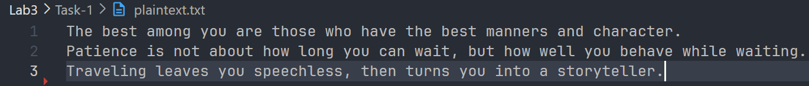

**Key and IV used** (hex values):

Key: 00112233445566778889aabbccddeeff

IV : 0102030405060708

## **AES-128-CBC**

**Encryption:**

| openssl enc -aes-128-cbc -e -in plaintext.txt -out cipher_cbc.bin \ -K 00112233445566778889aabbccddeeff \ -iv 0102030405060708 |
| --- |

**Decryption:**

| openssl enc -aes-128-cbc -d -in cipher_cbc.bin -out decrypted_cbc.txt \ -K 00112233445566778889aabbccddeeff \ -iv 0102030405060708 |
| --- |

**CBC Encrypted binary file:**

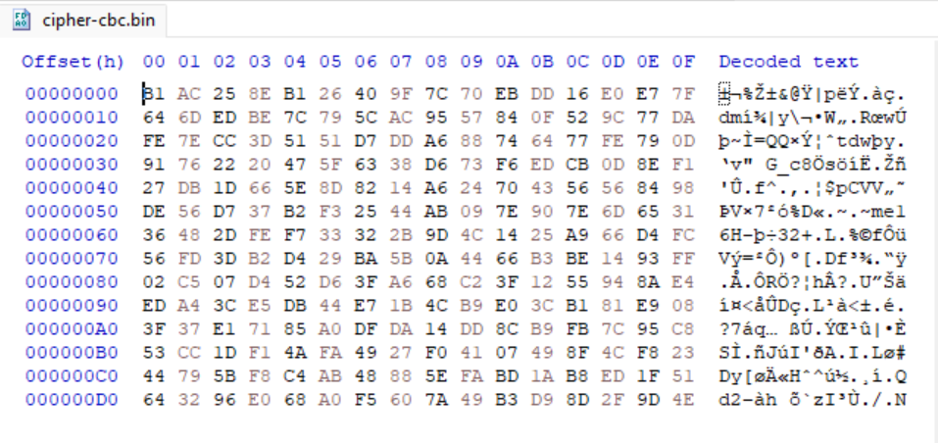

## **AES-128-CFB**

**Encryption:**

| openssl enc -aes-128-cfb -e -in plaintext.txt -out cipher_cfb.bin \ -K 00112233445566778889aabbccddeeff \ -iv 0102030405060708 |
| --- |

**Decryption:**

| openssl enc -aes-128-cfb -d -in cipher_cfb.bin -out decrypted_cfb.txt \  -K 00112233445566778889aabbccddeeff \  -iv 0102030405060708 |
| --- |

**CFB Encrypted binary file:**

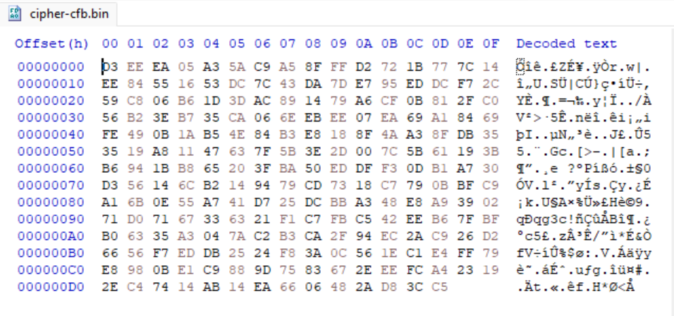

## **AES-128-OFB**

**Encryption:**

| openssl enc -aes-128-ofb -e -in plaintext.txt -out cipher_ofb.bin \  -K 00112233445566778889aabbccddeeff \  -iv 0102030405060708 |
| --- |

**Decryption:**

| openssl enc -aes-128-ofb -d -in cipher_ofb.bin -out decrypted_ofb.txt \  -K 00112233445566778889aabbccddeeff \  -iv 0102030405060708 |
| --- |

**OFB Encrypted binary file:**

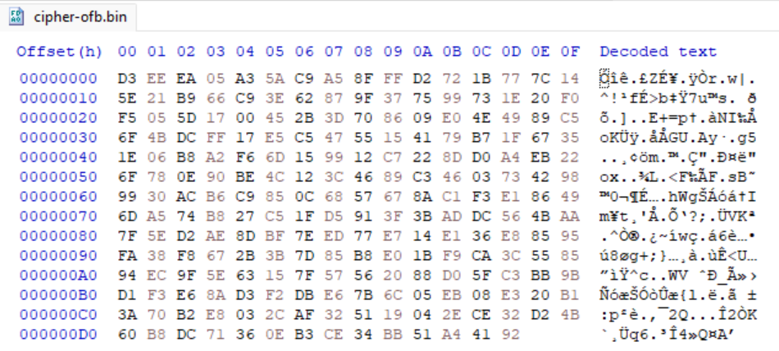

## **Observations**

* All modes successfully encrypted and decrypted the file.
* Only **CBC mode required padding**, because CBC is a block mode.
* **CFB and OFB work as stream modes**, so no padding was used.

# **Task 2 — ECB vs CBC Image Encryption**

For this task, I worked with the provided BMP file:

*pic_original.bmp*

I encrypted the file using AES-128-ECB and AES-128-CBC.

## **ECB Mode**

| openssl enc -aes-128-ecb -e -in pic_original.bmp -out pic_ecb.bmp \ -K 00112233445566778889aabbccddeeff |
| --- |

## **CBC Mode**

| openssl enc -aes-128-cbc -e -in pic_original.bmp -out pic_cbc.bmp \ -K 00112233445566778889aabbccddeeff \ -iv 0102030405060708 |
| --- |

## **Replacing the BMP Header**

The first **54 bytes** of a BMP file contain header information.  
 To treat the encrypted image as a real BMP, I:

1. Opened both pic_original.bmp and pic_ecb.bmp in ghex
2. Copied the first **54 bytes** from the original image
3. Pasted them into pic_ecb.bmp and pic_cbc.bmp

Selecting and copying offset until 36 for getting first 54 bytes from pic_original.bmp

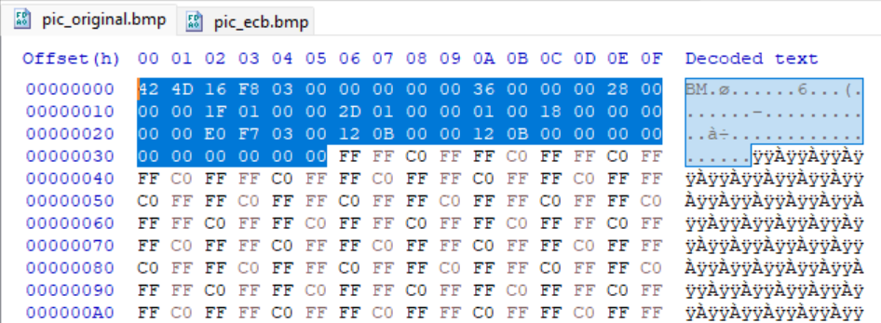

Pasting the first 54 bytes header from pic_original.bmp to pic_ecb.bmp and pic_cbc.bmp

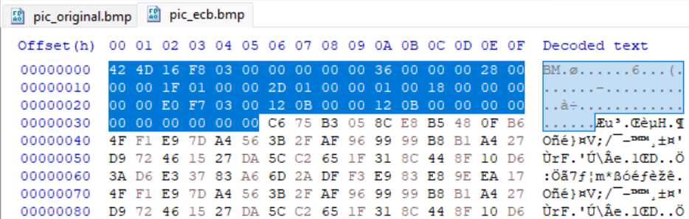

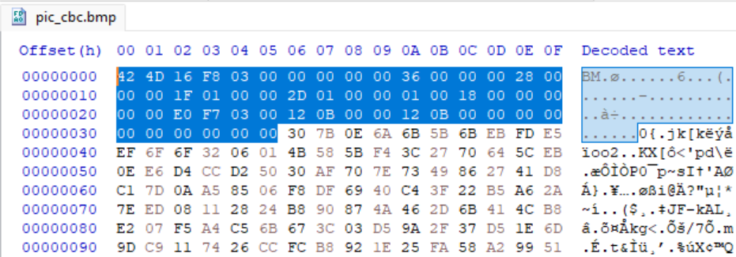

## **Observations**

Pic_original.bmp



### 

### 

### **ECB Output**

Pic_ecb.bmp



* The structure of the original picture is clearly visible.
* The shapes and general layout remained recognizable.
* Colors were changed, but the image pattern was still obvious.

**Reason:** ECB encrypts each block independently, so identical blocks produce identical ciphertext blocks → patterns leak.

### 

### 

### 

### 

### 

### 

### 

### **CBC Output**

Pic_ecb.bmp



* The picture looked like pure noise.
* No structure of the original image was visible.

**Reason:**CBC XORs each block with the previous block, breaking visual repetition and producing a much safer encrypted image.

# **Task 3 — Corrupted Cipher Text**

I used the same plaintext.txt which is **at least 64 bytes long**:



I encrypted using AES-128 in several modes.

Example (ECB):

| openssl enc -aes-128-ecb -e -in plaintext.txt -out cipher_ecb.bin \ -K 00112233445566778889aabbccddeeff |
| --- |

Example (CBC):

| openssl enc -aes-128-cbc -e -in plaintext.txt -out cipher_cbc.bin \ -K 00112233445566778889aabbccddeeff \ -iv 0102030405060708 |
| --- |

Example (CFB):

| openssl enc -aes-128-cfb -e -in plaintext.txt -out cipher_cfb.bin \ -K 00112233445566778889aabbccddeeff \ -iv 0102030405060708 |
| --- |

Example (OFB):

| openssl enc -aes-128-ofb -e -in plaintext.txt -out cipher_ofb.bin \ -K 00112233445566778889aabbccddeeff \ -iv 0102030405060708 |
| --- |

## **Bit Flip in 30th Byte**

Using GHex, I navigated to byte index 30 and flipped one bit manually.

## **Decryption Results**

### **ECB**

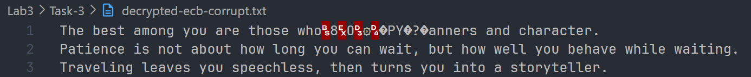

* The block containing the corrupted byte was fully damaged.
* All other blocks decrypted correctly.

### **CBC**

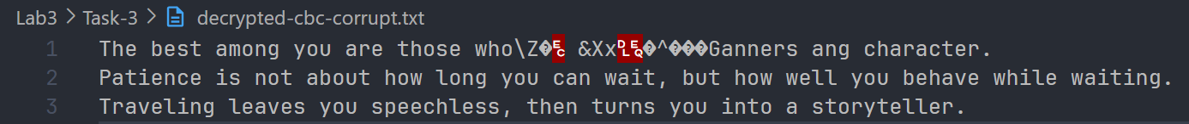

* The corrupted block was damaged.
* The following block was also affected (due to XOR dependency).
* Everything after that decrypted correctly.

### **CFB**

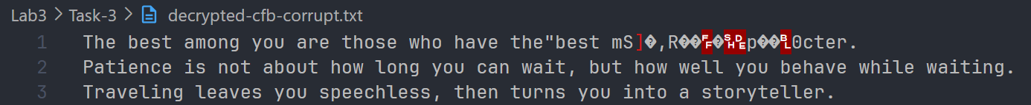

* Only one byte was corrupted.
* Rest of the file was intact.

### **OFB**



* Only that specific byte changed.
* OFB behaves like a stream cipher → independent of previous blocks.

## **Explanation**

* **ECB:** block-independent, so corruption stays inside the block.
* **CBC:** corruption propagates one block ahead.
* **CFB/OFB:** stream modes limit error propagation to 1 byte.

## **Implication**

* **ECB is unsafe** for any real application.
* **CBC is more secure**, but minor corruption affects multiple blocks.
* **CFB/OFB** are more resilient to noise and transmission errors.

# **Task 4 — Padding Behavior**

I created a new plaintext.txt file with a short sentence of character count and byte size 20.

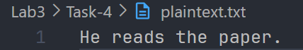

### **Padding comparison between different AES modes**

| **Mode** | **Padding Needed?** | **Why** |
| --- | --- | --- |
| **ECB** | Yes | Works in 16-byte blocks |
| **CBC** | Yes | Works in 16-byte blocks |
| **CFB** | No | Stream-style mode |
| **OFB** | No | Stream-style mode |

Example (ECB):

| openssl enc -aes-128-ecb -e -in plaintext.txt -out cipher-ecb-pad.bin -K 00112233445566778889aabbccddeeff |
| --- |

Example (CBC):

| openssl enc -aes-128-cbc -e -in plaintext.txt -out cipher-cbc-pad.bin -K 00112233445566778889aabbccddeeff -iv 0102030405060708 |
| --- |

Example (CFB):

| openssl enc -aes-128-cfb -e -in plaintext.txt -out cipher_cfb-pad.bin  -K 00112233445566778889aabbccddeeff -iv 0102030405060708 |
| --- |

Example (OFB):

| openssl enc -aes-128-ofb -e -in plaintext.txt -out cipher_ofb-pad.bin  -K 00112233445566778889aabbccddeeff -iv 0102030405060708 |
| --- |

## **Observations:**

I checked the length of all the padded binary files with this command

| ls -l cipher_mode_pad.bin |
| --- |

**ECB Mode:**

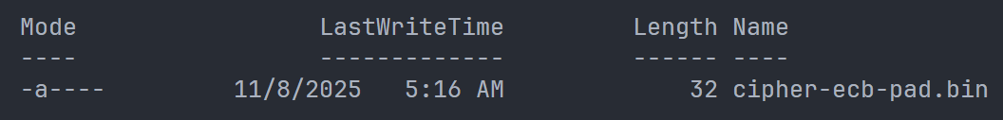

**CBC Mode:**

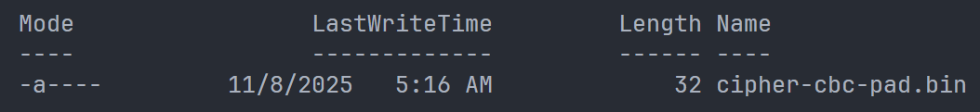

**CFB Mode:**

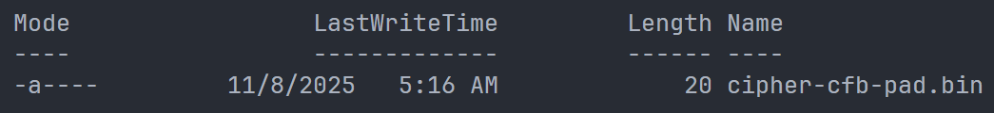

**OFB Mode:**

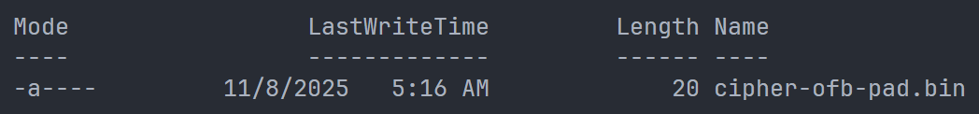

### **Conclusion:**

* **ECB/CBC:** Rounded up to the next multiple of 16 (32 bytes).
* **CFB/OFB**: Stayed the exact size of the input file (20 bytes).

# **Task 5 — Generating Message Digests**

I used OpenSSL’s dgst command to hash plaintext.txt.

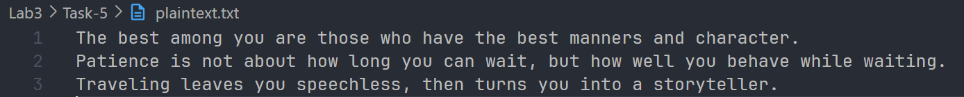

### **MD5**

| openssl dgst -md5 plaintext.txt |
| --- |

### **SHA1**

| openssl dgst -sha1 plaintext.txt |
| --- |

### **SHA256**

| openssl dgst -sha256 plaintext.txt |
| --- |

### **Generated Hashes:**

**MD5**



**SHA1**



**SHA256**



## **Observations**

* MD5 produces a 128-bit digest (shorter).
* SHA1 produces a 160-bit digest.
* SHA256 produces a much longer 256-bit digest.

# 

# **Task 6 — HMAC**

I have used the same plaintext.txt for generating hmac. I generated HMACs using different algorithms.

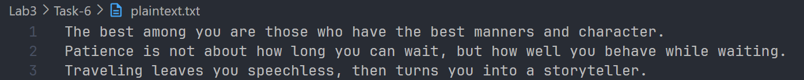

### 

### 

### **HMAC-MD5**

**Short Key:**

| openssl dgst -md5 -hmac "key-1" plaintext.txt |
| --- |

**Long Key:**

| openssl dgst -md5 -hmac "thisisalongkeywithmanycharacters" plaintext.txt |
| --- |

### 

### **HMAC-SHA1**

**Short Key:**

| openssl dgst -sha1 -hmac "key-1" plaintext.txt |
| --- |

**Long Key:**

| openssl dgst -sha1 -hmac "thisisalongkeywithmanycharacters" plaintext.txt |
| --- |

### 

### **HMAC-SHA256**

**Short Key:**

| openssl dgst -sha256 -hmac "key-1" plaintext.txt |
| --- |

**Long Key:**

| openssl dgst -sha256 -hmac "thisisalongkeywithmanycharacters" plaintext.txt |
| --- |

### **Generated Digests:**

**MD5**



**SHA1**



**SHA256**



## **Observations:**

* HMAC accepts keys of any length.
* HMAC doesn’t need keys of fixed length
* Long keys are hashed first.
* Short keys are padded automatically.
* Internally, HMAC normalizes keys to the hash block size.

# **Task 7 — Randomness of One-Way Hash**

I have used the same plaintext.txt file for this task.



### 

### **Step-1: Hash Creation before Modification**

I have created hashes of the plaintext.txt with *md5* and *sha256* algorithm like normal.

**Commands:**

**MD5**

| openssl dgst -md5 plaintext.txt |
| --- |

**SHA256**

| openssl dgst -sha256 plaintext.txt |
| --- |

**Hashes:**

**MD5**



**SHA256**



### **Step-2: Modification**

I opened plaintext.txt with ghex and altered the first bit of the first offset of plainttext.txt.

**Before**

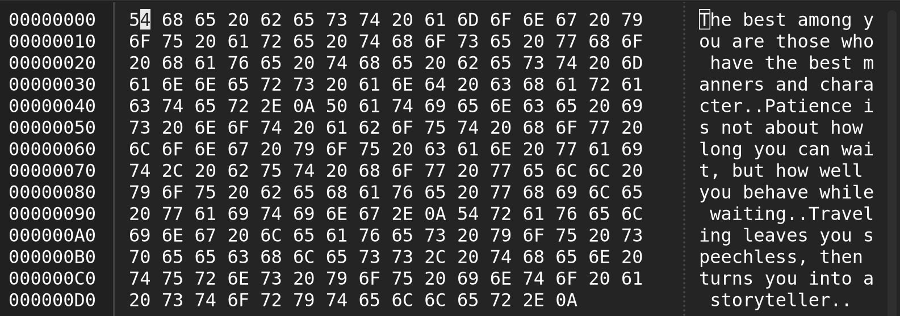

**After**

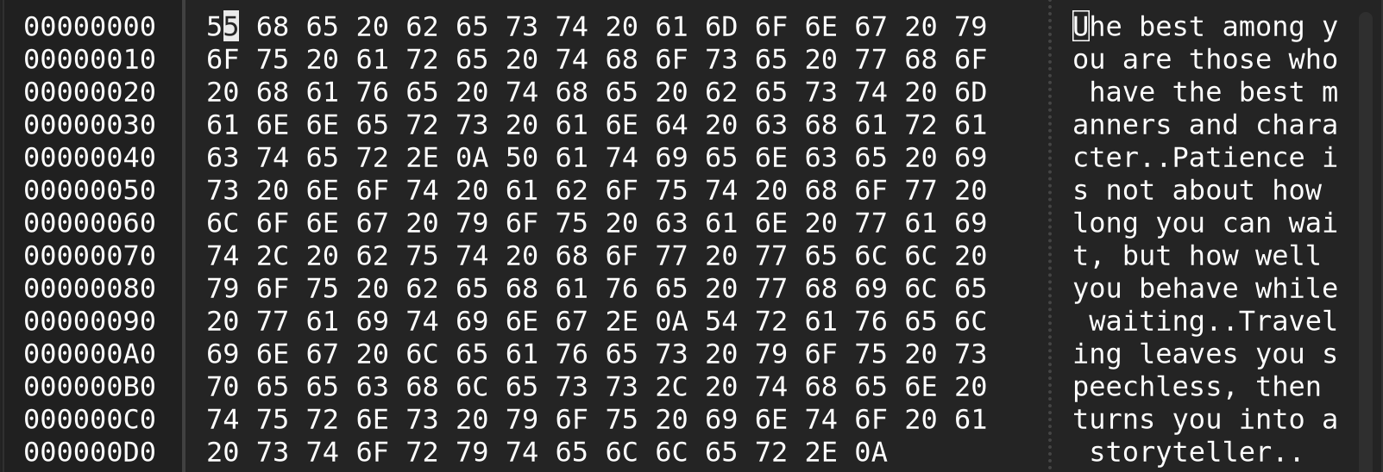

### **Step-3: Hash Creation after Modification**

**MD5**



**SHA256**



### **Bonus Step: Writing a Bit Counter Program**

I have created a python program that takes two hash values as inputs and compares the bits in both of the hashes finally showing the same and different bits with similarity percentage.

bitcounter.py

h1 = input("Enter first hash value in hex: ").strip()

h2 = input("Enter second hash value in hex: ").strip()

# Check if inputs are valid

if not h1 or not h2 or len(h1) != len(h2):

print("Please ensure both hashes are provided and have the same length.")

# Exit if inputs invalid

import sys

sys.exit(1)

# Convert hex string to integer to binary

b1 = bin(int(h1, 16))[2:].zfill(len(h1) * 4)

b2 = bin(int(h2, 16))[2:].zfill(len(h2) * 4)

# Count bit matches

same_bits = sum(1 for x, y in zip(b1, b2) if x == y)

diff_bits = len(b1) - same_bits

print(f"Total bits compared: {len(b1)}")

print(f"Number of same bits: {same_bits}")

print(f"Number of different bits: {diff_bits}")

percentage = (same_bits / len(b1)) * 100

print(f"Percentage of matching bits: {percentage:.2f}%")

## **Observation**

Comparison between the hashes generated with **MD5** calculated using the bitcounter.py program.

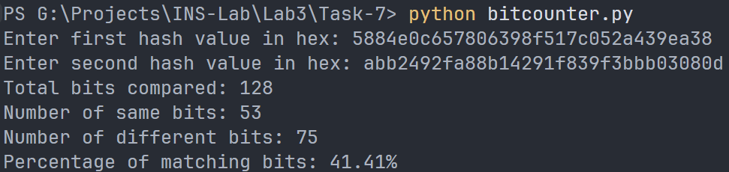

Comparison between the hashes generated with **SHA256** calculated using the bitcounter.py program.

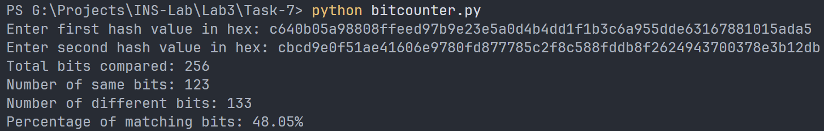

* After modifying only a single bit in the file, both MD5 and SHA-256 produced completely different hash values.
* For MD5, 75 out of 128 bits (≈58.6%) flipped.  
  For SHA-256, 133 out of 256 bits (≈52%) flipped.

In both cases, more than half of the digest bits changed, which confirms the avalanche effect in cryptographic hash functions — even the smallest change in input results in a large, unpredictable change in the hash output.

# 

# **Lab Report — Programming Symmetric & Asymmetric Cryptography**

## **1. Objective**

The objective of this lab is to **implement symmetric and asymmetric cryptography** using a single command-line program that simulates the behavior of the OpenSSL tool.

Specifically, the program performs:

* AES Encryption & Decryption (ECB & CFB modes, 128/256-bit keys)
* RSA Encryption & Decryption
* RSA Digital Signature Generation & Verification
* SHA-256 Hashing of files
* Timing Measurement for AES and RSA operations

## **2. Tools and Environment**

| **Tool** | **Description** |
| --- | --- |
| **Operating System** | Windows 11 |
| **Programming Language** | Python 3 |
| **Cryptography Backend** | System OpenSSL via subprocess |
| **Required Files** | cryptic_cli_tool.py, message.txt, signature.txt |
| **Generated Files** | RSA keys (.pem), AES keys (.key), encrypted/decrypted files, signatures, IVs |

## **3. Program Overview**

The Python program cryptic_cli_tool.py acts as a **menu-driven CLI wrapper** around OpenSSL commands.  
 It automatically generates keys on first run and allows the user to choose operations through numeric options.

**Main Menu:**

1) Generate keys (RSA & AES) [one time]

2) AES encrypt file

3) AES decrypt file

4) RSA encrypt file

5) RSA decrypt file

6) RSA sign file (SHA-256)

7) RSA verify signature

8) SHA-256 hash file

9) Timing experiment (RSA key sizes)

10) Timing experiment (AES modes/key sizes)

0) Exit

## 

## 

## 

## 

## 

## 

## **4. Implementation Details**

### **Option 1 – Generate Keys**

This option creates:

* **RSA 2048-bit key pair**:  
   rsa_private.pem, rsa_public.pem
* **AES keys**:  
   aes_key_128.key (16 bytes), aes_key_256.key (32 bytes)

Keys are stored locally for later reuse.

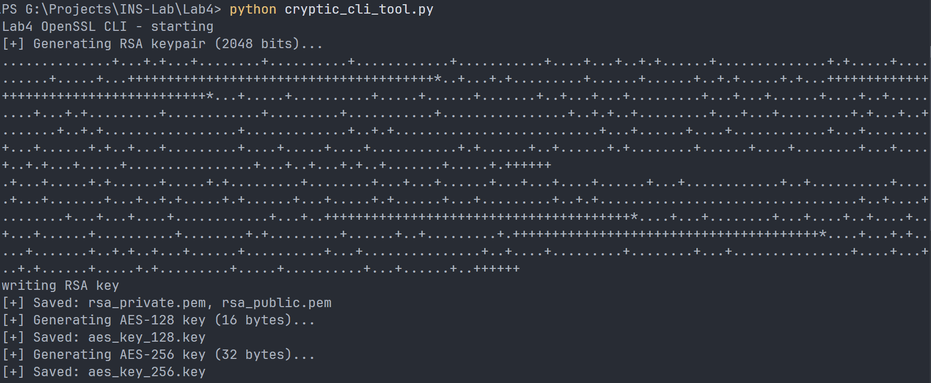

### 

### 

### **Option 2 – AES Encryption**

Encrypts a plaintext file using OpenSSL’s AES algorithm.  
User selects **key length** (128 or 256 bits) and **mode** (ECB or CFB).

* The resulting ciphertext is saved in .enc file.
* In CFB mode, an IV is also generated (.enc.iv).
* Execution time is displayed.

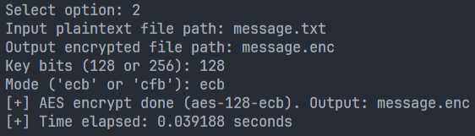

**Message.enc file**

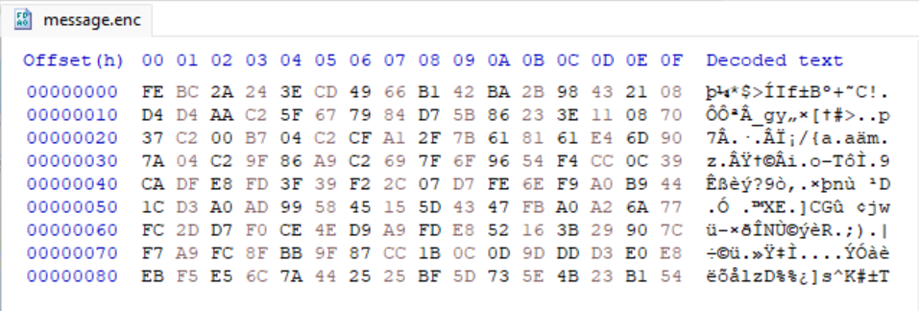

### **Option 3 – AES Decryption**

Decrypts a previously encrypted file using the same key and mode.  
Displays the original plaintext on screen for verification.

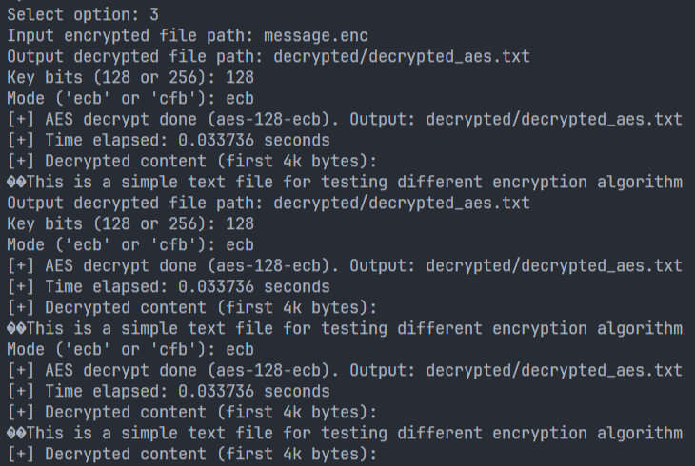

### **Option 4 – RSA Encryption**

Encrypts a small text file using the RSA public key (rsa_public.pem).  
RSA is slow and meant for short messages or key exchange only.  
The output binary ciphertext is saved as .enc.

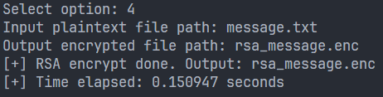

### **Option 5 – RSA Decryption**

Decrypts the RSA-encrypted file using the private key (rsa_private.pem).  
Shows the recovered plaintext in console to prove successful decryption.

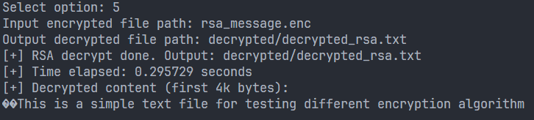

### **Option 6 – RSA Digital Signature Generation**

Generates a **SHA-256 hash** of the input file and signs it using the RSA private key.  
The signature is stored in a binary .sig file.

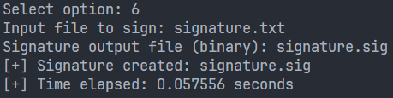

### **Option 7 – RSA Signature Verification**

Verifies the signature using the RSA public key and the original file.  
If the file is unaltered, OpenSSL prints **“Verified OK”**.

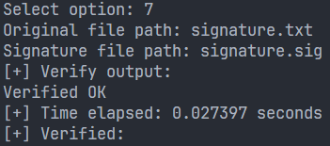

### **Option 8 – SHA-256 Hashing**

Computes a SHA-256 digest of any file and prints it to the console.  
This is commonly used for integrity checking and file fingerprinting.



### **Option 9 – RSA Timing Experiment**

Automatically generates temporary RSA keys of different sizes (512 → 4096 bits) and measures the encryption/decryption times.  
Results are printed as a table.  
These values can be used to plot RSA key size vs execution time.

**Message.txt**(small size)  
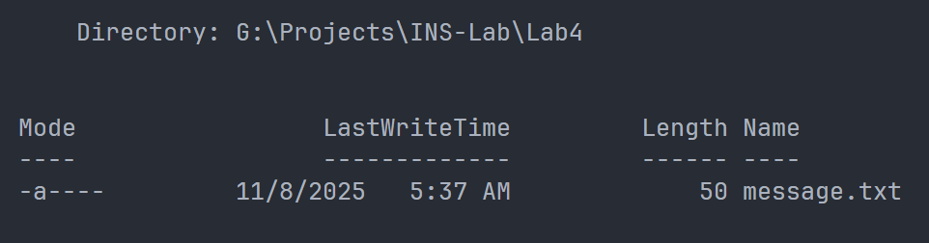

**RSA Results**

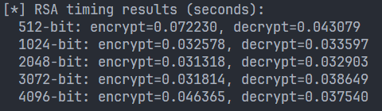

### **Option 10 – AES Timing Experiment**

Measures the execution time of AES encryption and decryption for:

* AES-128-ECB **: 0.283255 seconds** **| 0.025837 seconds**
* AES-128-CFB **: 0.026455 seconds | 0.024036 seconds**
* AES-256-ECB **: 0.026533 seconds | 0.026006 seconds**
* AES-256-CFB **: 0.025252 seconds | 0.024015 seconds**

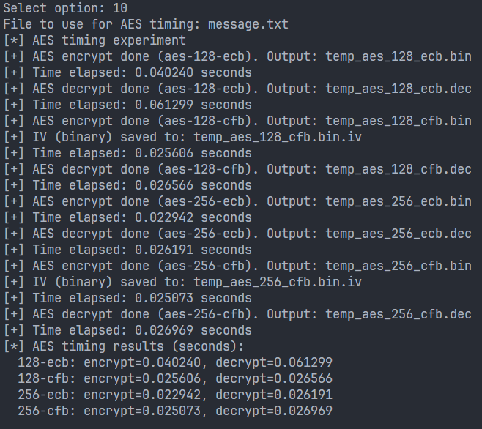

## **5. Conclusion**

In this lab, we successfully implemented and tested various cryptographic operations using OpenSSL through a Python interface.  
 The program demonstrated the mechanics of:

* Key generation and management
* Symmetric vs asymmetric encryption
* Digital signatures and integrity checking
* Performance measurement of cryptographic algorithms

## **6. References**

1. OpenSSL Manual Pages –<https://www.openssl.org/docs/manmaster/>
2. Python subprocess Module Documentation –<https://docs.python.org/3/library/subprocess.html>
3. Lab Manual 4 – CSE-478 (Department of Computer Science & Engineering)

# **Lab Report — Securing Apache Web Server with SSL/TLS**

## **Objective**

The purpose of this lab is to:

* Learn how to create and use **self-signed SSL/TLS certificates** using OpenSSL.
* Configure **Apache Web Server** to serve websites securely over HTTPS.
* Understand the basic concept of **encryption and authentication** on the web.

## **Overview (in Simple Terms)**

Normally, when we use a website with http://, the data travels in plain text.  
Anyone in the middle can see it — which is **not secure**.

Using **HTTPS (SSL/TLS)**:

* Encrypts the communication between browser and server.
* Prevents hackers from reading or modifying the data.
* Uses **certificates** to prove the website’s identity.

In real life, these certificates come from trusted companies called **Certificate Authorities (CAs)**.  
In this lab, I created my **own CA** and used it to issue certificates for my local Apache sites.

## **Tools Used**

* **Ubuntu Linux**
* **Apache2 Web Server**
* **OpenSSL**
* **Firefox**
* **Terminal & Text Editor (nano)**

## **Step-by-Step Procedure**

### **Step 1: Prepare the Workspace**

I first created a folder to store all our certificate files:

| mkdir -p ~/lab5-ca && cd ~/lab5-ca |
| --- |

Then copied the OpenSSL config file:

| cp /etc/ssl/openssl.cnf ./openssl.cnf |
| --- |

### **Step 2: Create a Root Certificate Authority (CA)**

A CA is like an ID authority that signs certificates for others.  
We created folders for our CA database:

| mkdir -p demoCA/{certs,crl,newcerts,private} touch demoCA/index.txt echo 1000 > demoCA/serial |
| --- |

Then I generated a **self-signed CA certificate**:

| openssl req -new -x509 -days 3650 -extensions v3_ca \  -keyout demoCA/private/ca.key -out demoCA/ca.crt \  -config ./openssl.cnf |
| --- |

This created two files:

* ca.key → private key (keep it secret)
* ca.crt → your CA certificate

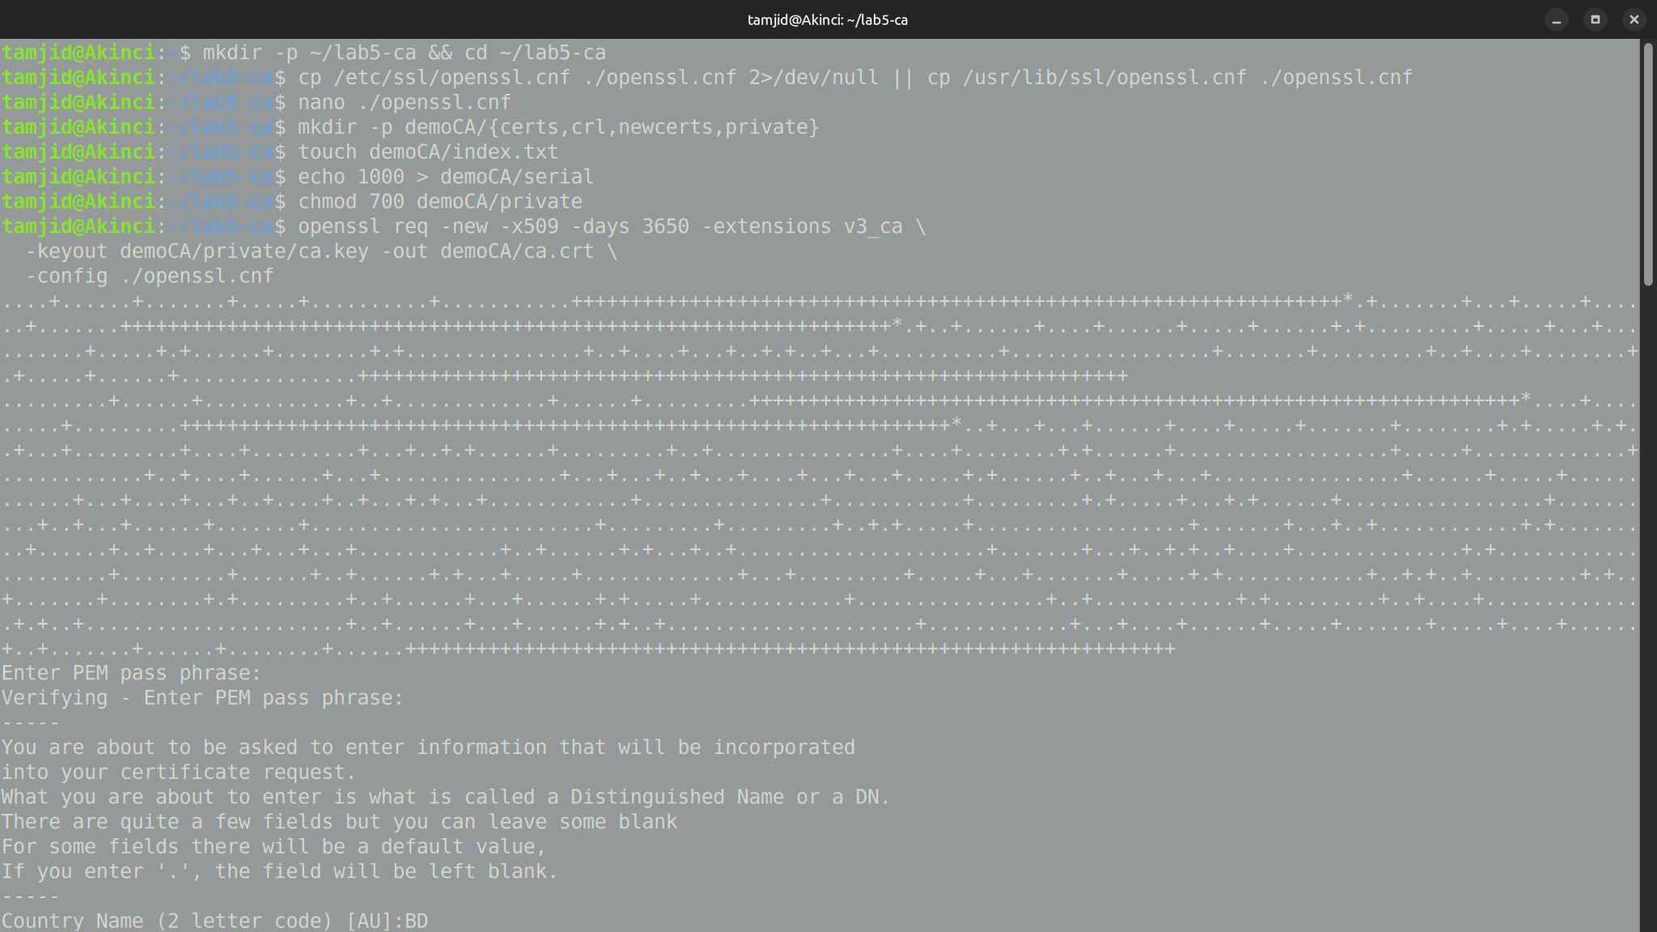

### **Step 3: Create a Key and Certificate Request for the Server**

Next, I generated a private key for our website:

| openssl genrsa -des3 -out server.key 2048 |
| --- |

Then created a **CSR (Certificate Signing Request)**:

| openssl req -new -key server.key -out server.csr -config ./openssl.cnf |
| --- |

When asked for “Common Name,” I entered:

example.com

This request will later be signed by our CA.

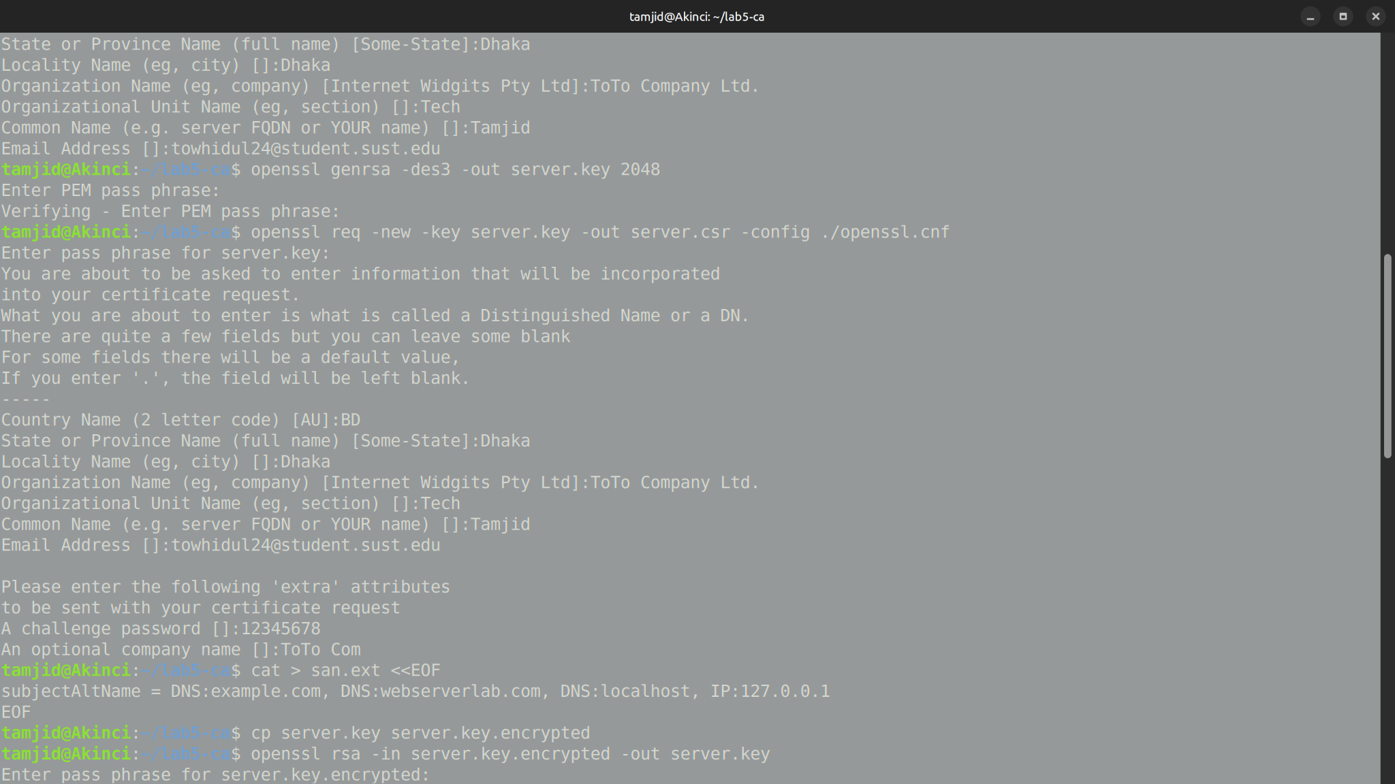

### **Step 4: Add SAN (Subject Alternative Names)**

To make the certificate valid for multiple domains (like example.com, localhost),  
 we created a file named san.ext:

subjectAltName = DNS:example.com, DNS:webserverlab.com, DNS:localhost, IP:127.0.0.1

This ensures browsers won’t complain about mismatched hostnames.

### **Step 5: Sign the Certificate with Our CA**

We used our CA to sign the CSR and generate the actual certificate:

| openssl x509 -req -in server.csr -CA demoCA/ca.crt -CAkey demoCA/private/ca.key \  -CAcreateserial -out server.crt -days 825 -sha256 -extfile san.ext |
| --- |

Now we have:

* server.crt → signed certificate
* server.key → server’s private key

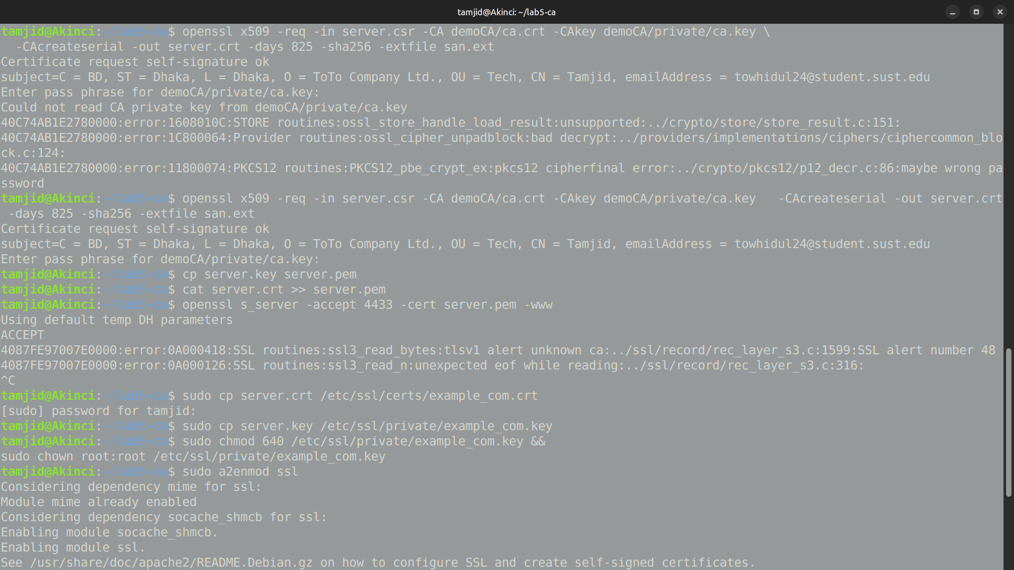

### **Step 6: Test HTTPS with OpenSSL**

Before using Apache, we tested our certificate with OpenSSL’s built-in web server:

| cp server.key server.pem cat server.crt >> server.pem |
| --- |

| openssl s_server -accept 4433 -cert server.pem -www |
| --- |

Then opened a browser and went to:

https://localhost:4433

At first, it showed a warning because the browser didn’t yet trust our CA.

### **Step 7: Import Root CA into Browser**

We added our CA to Firefox so it trusts our certificates:

**In Firefox:**

1. Go to **Settings → Privacy & Security → Certificates → View Certificates**

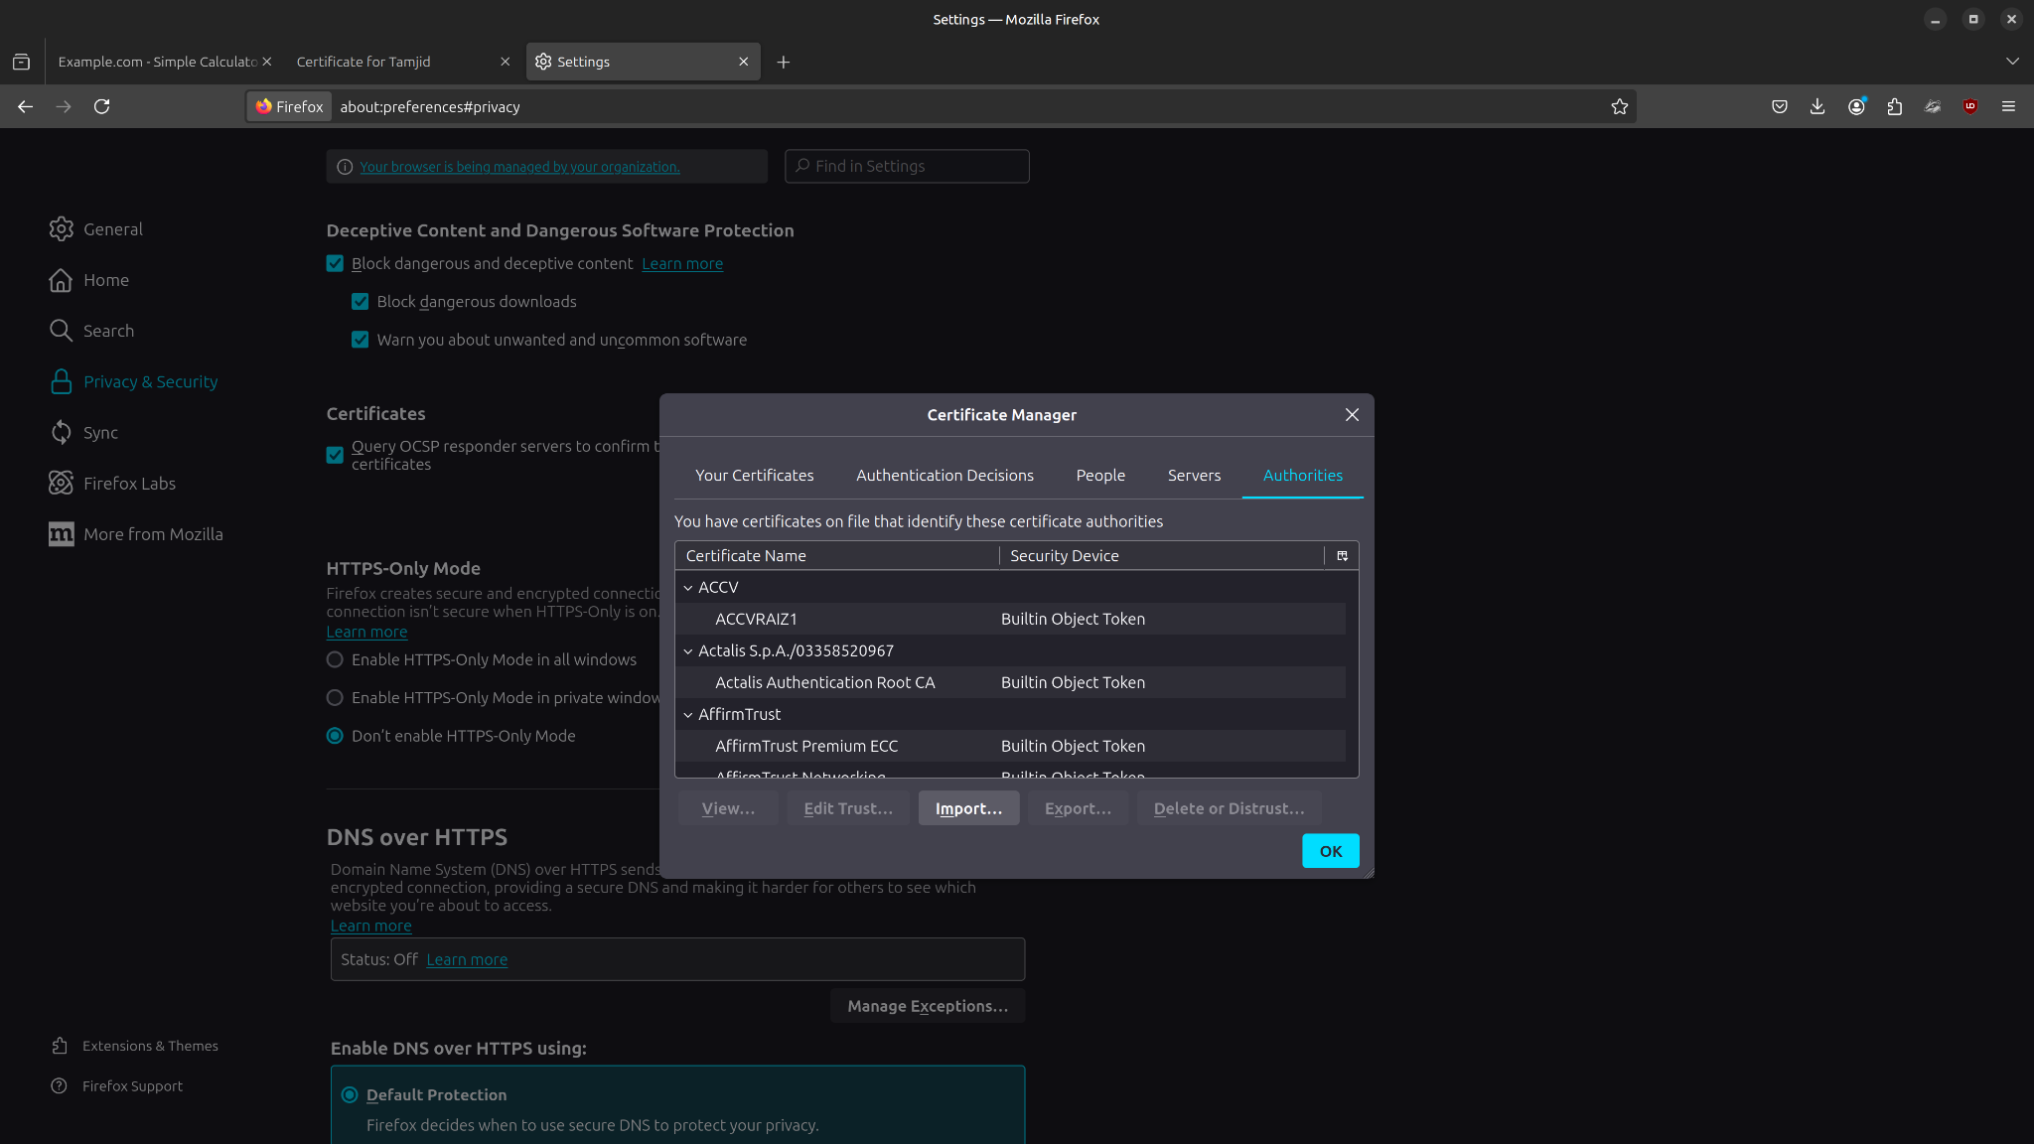

1. Click **Import…** and select demoCA/ca.crt

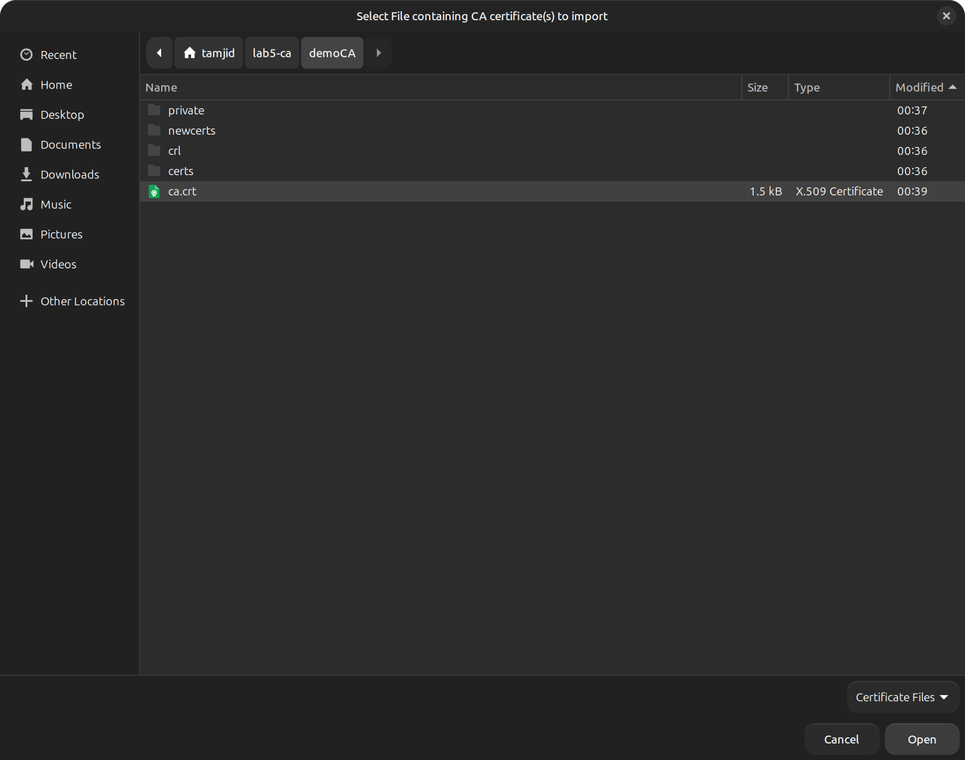

1. Check **Trust this CA to identify websites  
   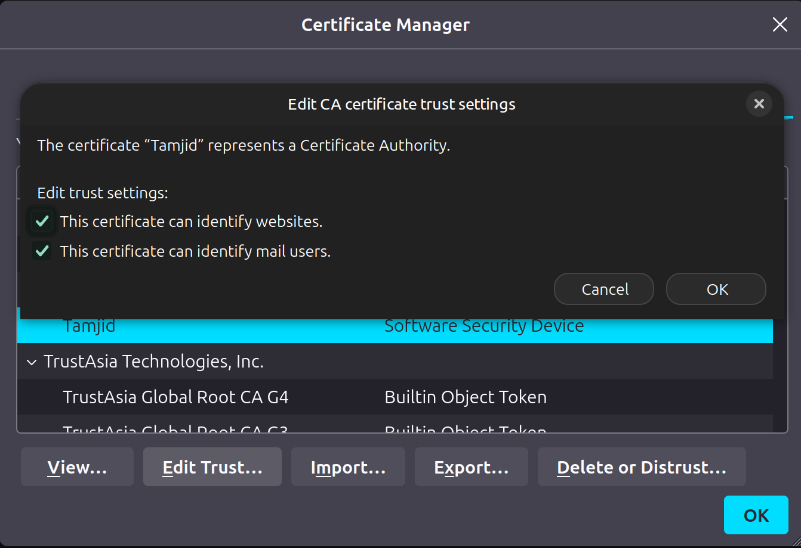**

Certificate details in Firefox browser

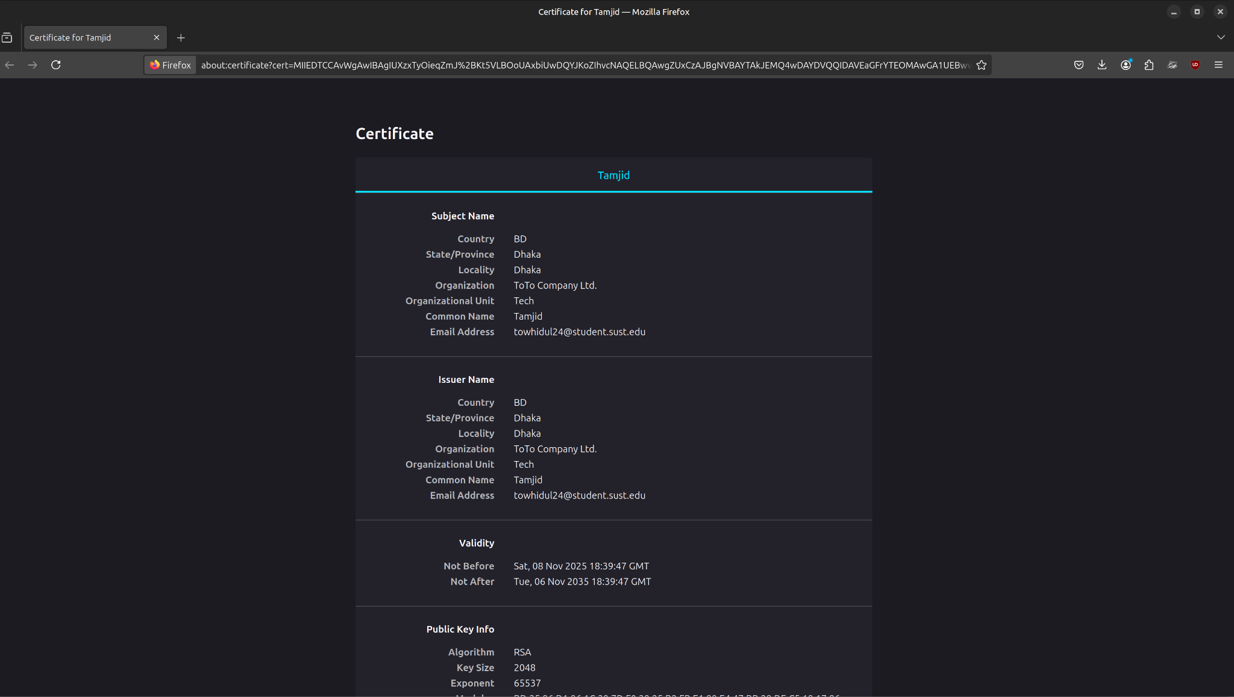

After that, refreshing the site showed a **padlock icon** — meaning HTTPS is working and trusted.

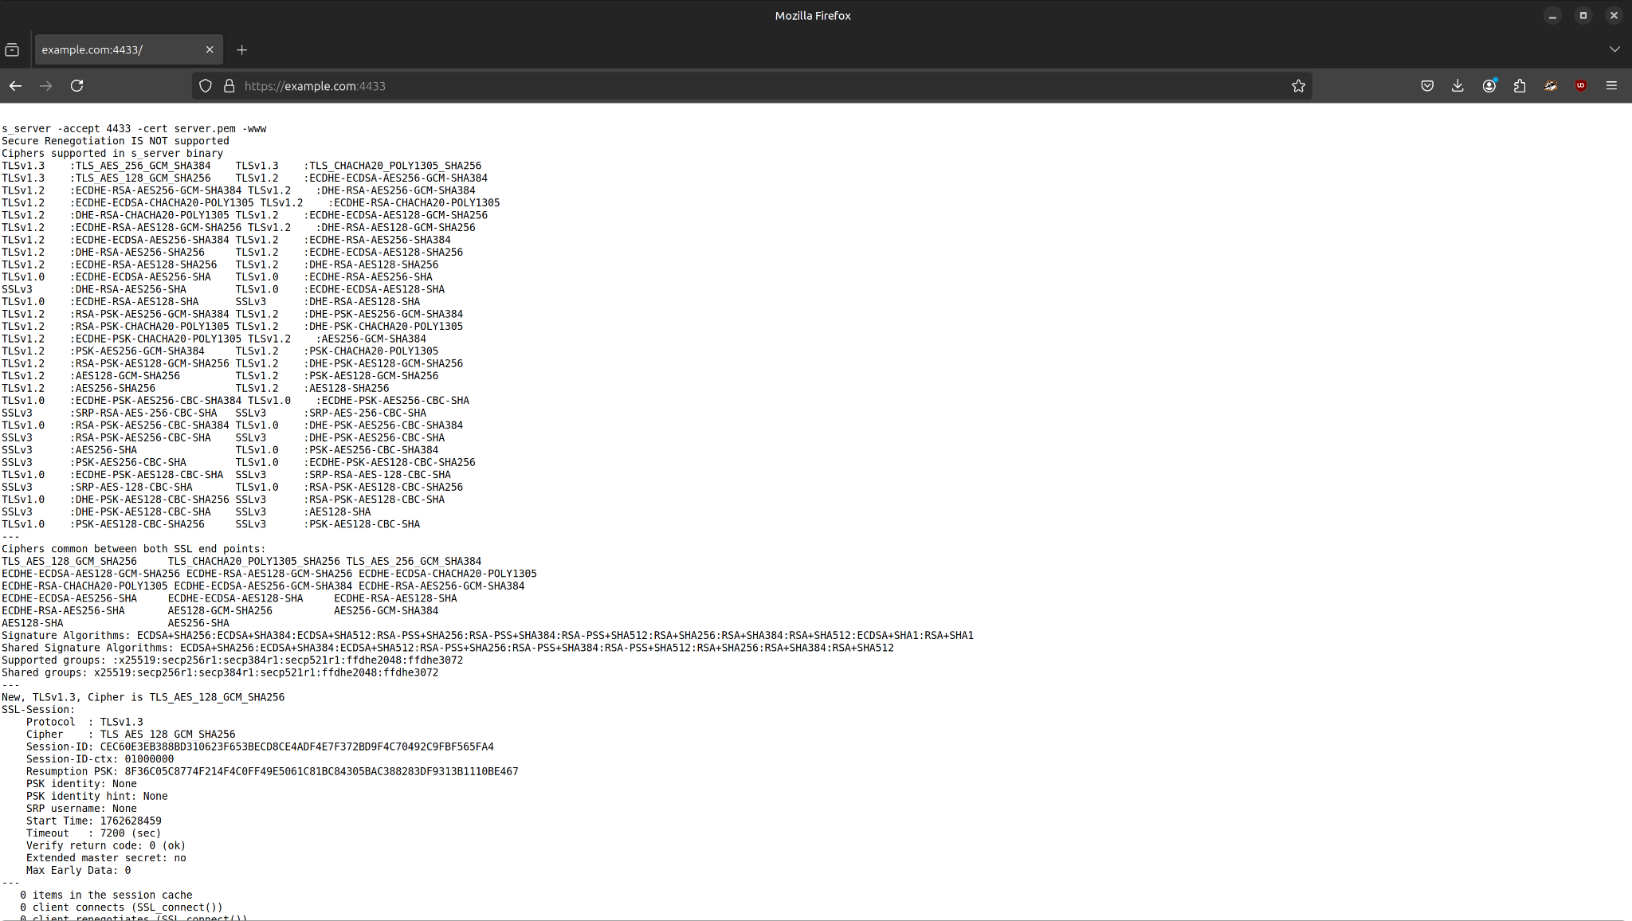

### **Step 8: Configure Apache for HTTPS**

We copied the certificate and key to system folders:

| sudo cp server.crt /etc/ssl/certs/example_com.crt |
| --- |

| sudo cp server.key /etc/ssl/private/example_com.key |
| --- |

Enabled SSL module:

| sudo a2enmod ssl sudo systemctl restart apache2 |
| --- |

Then edited the Apache virtual host file:

| sudo nano /etc/apache2/sites-available/example.com.conf |
| --- |

Added this block:

| <IfModule mod_ssl.c> <VirtualHost *:443>  ServerAdmin admin@example.com  ServerName example.com  DocumentRoot /var/www/example.com/html   SSLEngine on  SSLCertificateFile /etc/ssl/certs/example_com.crt  SSLCertificateKeyFile /etc/ssl/private/example_com.key   ErrorLog ${APACHE_LOG_DIR}/example_ssl_error.log  CustomLog ${APACHE_LOG_DIR}/example_ssl_access.log combined </VirtualHost> </IfModule> |
| --- |

**Tested configuration:**

| sudo apache2ctl configtest sudo systemctl restart apache2 |
| --- |

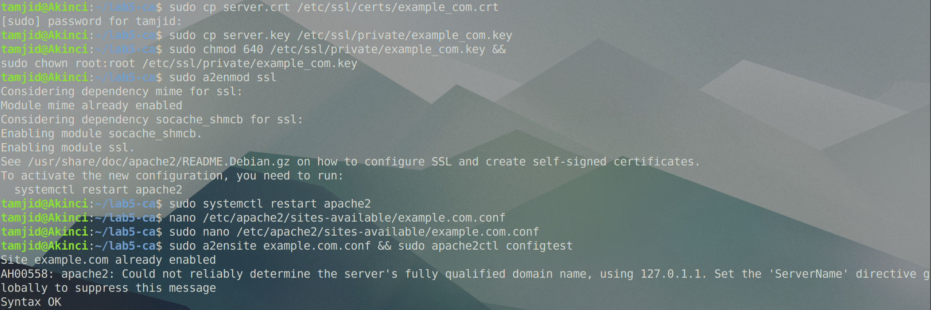

### **Step 9: Verify HTTPS Website**

Finally, we opened:

https://example.com

and saw the page load successfully with a **secure padlock** in the address bar.

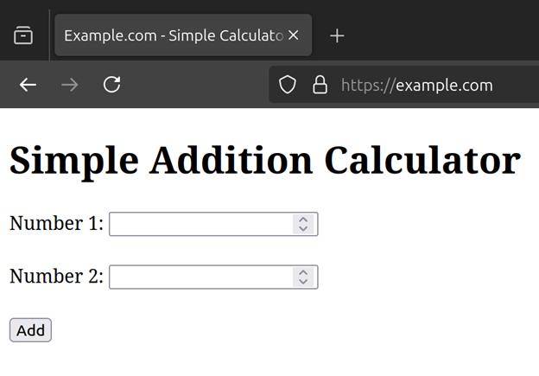

## **Results**

| **Task** | **Description** | **Status** |
| --- | --- | --- |
| 1 | Created self-signed CA | Completed |
| 2 | Generated server certificate | Completed |
| 3 | Tested HTTPS using OpenSSL | Completed |
| 4 | Imported CA into browser | Completed |
| 5 | Configured Apache for HTTPS | Completed |

**Observations**

* HTTPS encrypts communication, making it safer than HTTP.
* Self-signed CAs can be used for learning and local development.
* Once the CA is imported, browsers treat our certificates as trusted.
* Apache needs SSL enabled (mod_ssl) to handle HTTPS requests.
* The padlock icon proves encryption and certificate trust.

# **Web Lab Report — Apache Web Server**

## **Objective**

To install and configure Apache Web Server on Ubuntu, create and manage multiple virtual hosts, and understand how hostname resolution works using the /etc/hosts file.

## **Checkpoint-1: Apache Installation and Default Page**

### **Step 1.1 – Install Apache**

| sudo apt update |
| --- |

| sudo apt install apache2 -y |
| --- |

### **Step 1.2 – Allow Apache Through Firewall**

| sudo ufw allow 'Apache' |
| --- |

| sudo ufw status |
| --- |

### **Step 1.3 – Verify Apache Service**

| sudo systemctl status apache2 |
| --- |

Confirm it shows **active (running)**.

### **Step 1.4 – Add Local Domain**

Edit /etc/hosts and add:

| 127.0.0.1 localhost webserverlab.com |
| --- |

### **Step 1.5 – Test in Browser**

Visit:

http://webserverlab.com

You should see the **Apache2 Ubuntu Default Page**.

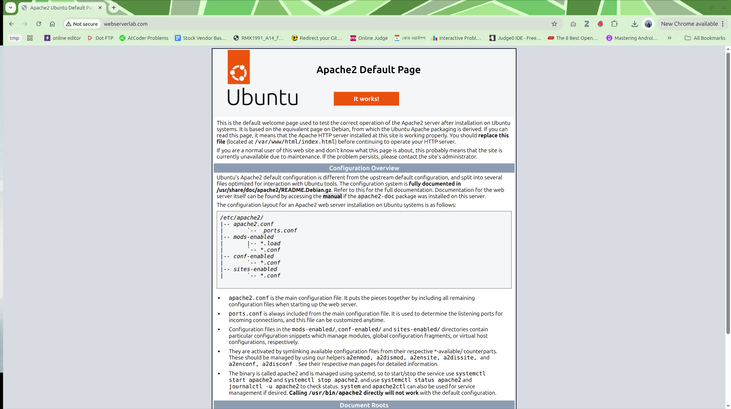

## **Checkpoint-2: Create and Configure First Virtual Host (example.com)**

### **Step 2.1 – Create Directory Structure and Provide Privilege for Ownership and Execution**

| sudo mkdir -p /var/www/example.com/html |
| --- |

| sudo chown -R $USER:$USER /var/www/example.com/html |
| --- |

| sudo chmod -R 755 /var/www/example.com |
| --- |

### **Step 2.2 – Create Website Content**

| nano /var/www/example.com/html/index.html |
| --- |

| <html>  <head><title>Welcome to Example.com!</title></head>  <body><h1>Success! example.com virtual host is working!</h1></body> </html> |
| --- |

### **Step 2.3 – Create Virtual Host Config**

| sudo nano /etc/apache2/sites-available/example.com.conf |
| --- |

| <VirtualHost *:80>  ServerAdmin admin@example.com  ServerName example.com  ServerAlias www.example.com  DocumentRoot /var/www/example.com/html   ErrorLog ${APACHE_LOG_DIR}/example_error.log  CustomLog ${APACHE_LOG_DIR}/example_access.log combined </VirtualHost> |
| --- |

### **Step 2.4 – Enable Site and Disable Default**

| sudo a2ensite example.com.conf |
| --- |

| sudo a2dissite 000-default.conf |
| --- |

| sudo systemctl restart apache2 |
| --- |

### **Step 2.5 – Update /etc/hosts**

| 127.0.0.1 localhost webserverlab.com example.com |
| --- |

### 

### **Step 2.6 – Test Site**

### Visit:

http://example.com

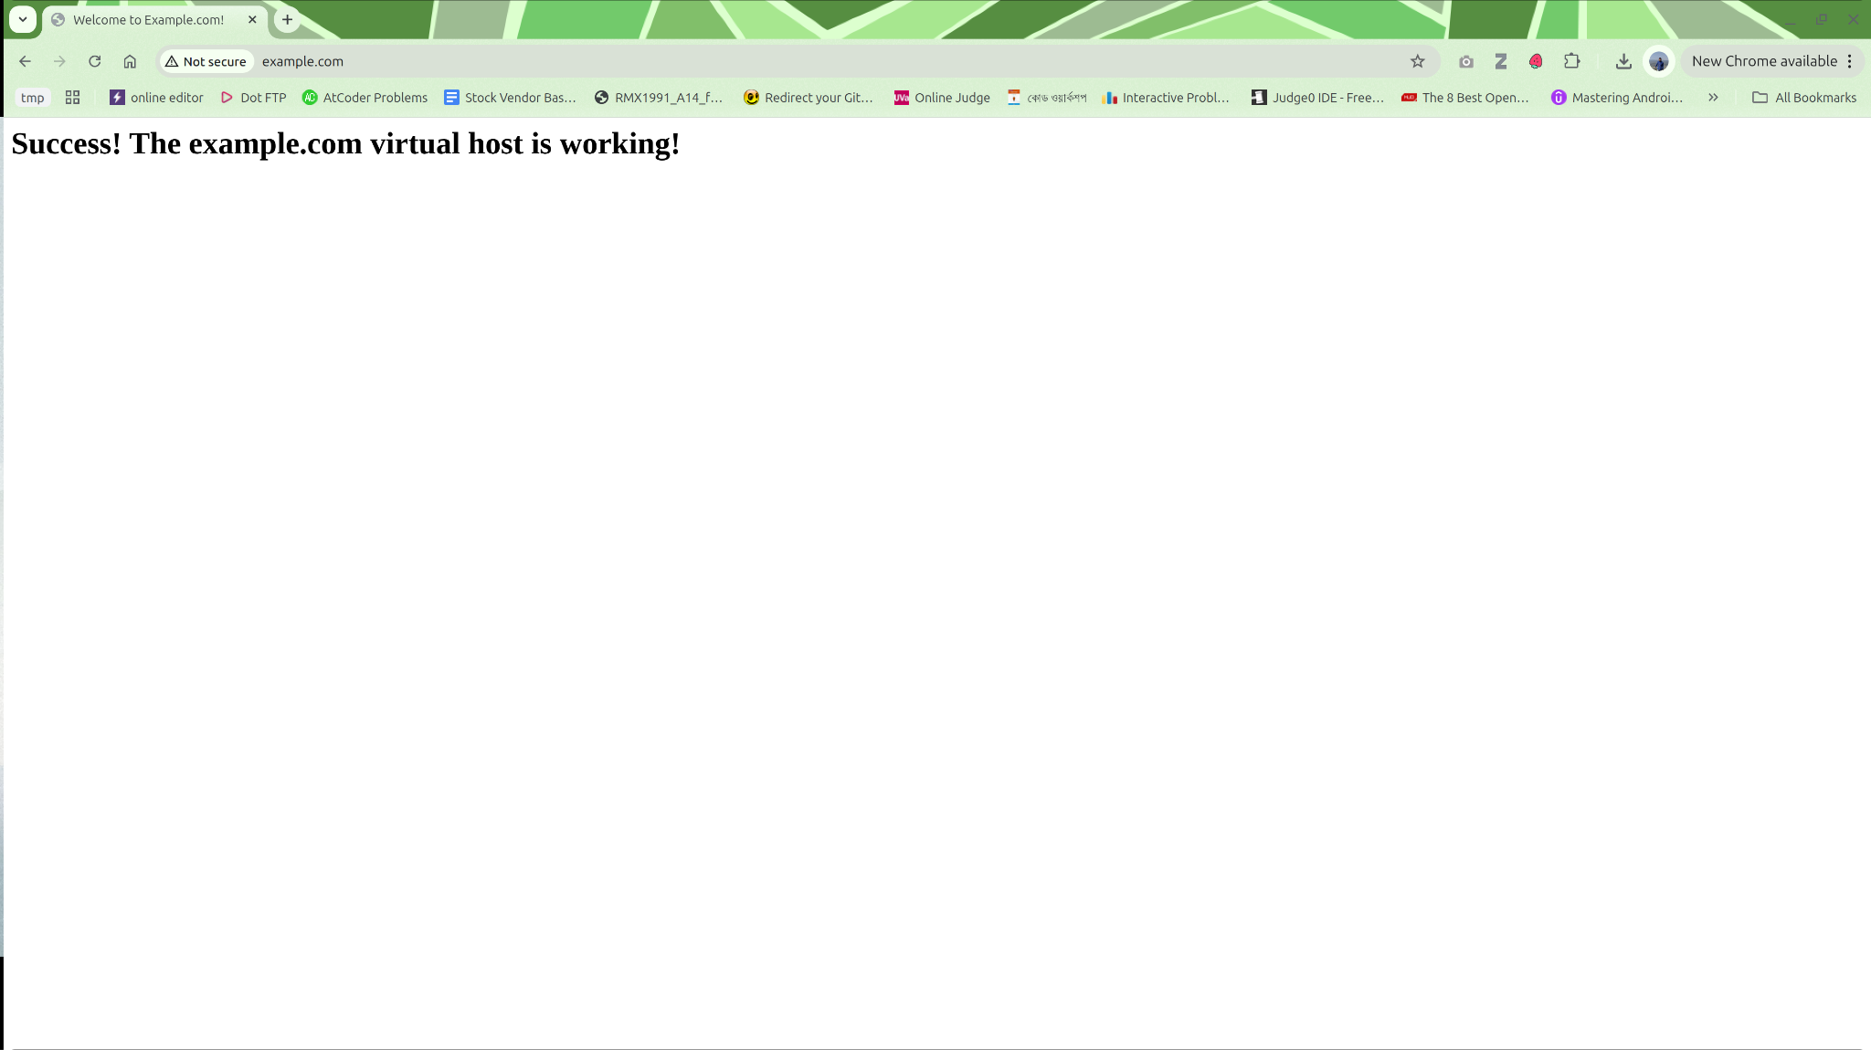

## 

## **Checkpoint-3: Observing Default Host Behavior**

Now visit:

http://webserverlab.com

http://anothervhost.com

Both URLs will load the same content as example.com.

**Reason:**When 000-default.conf is disabled, Apache uses the **first active virtual host** as the default for any unmatched request.

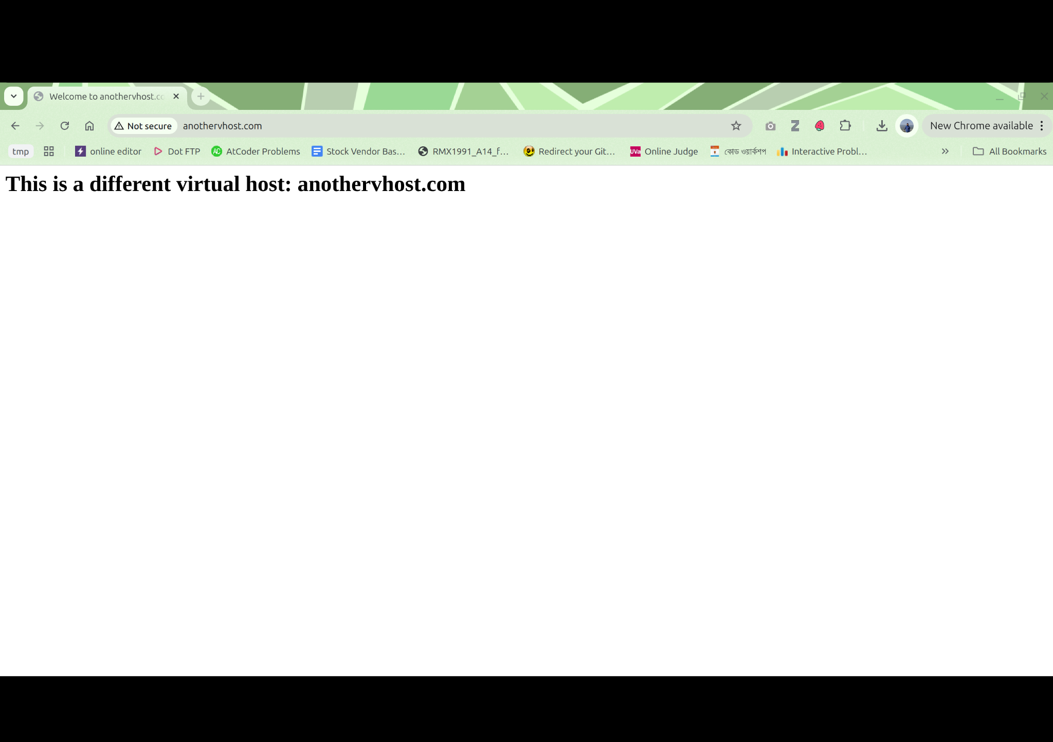

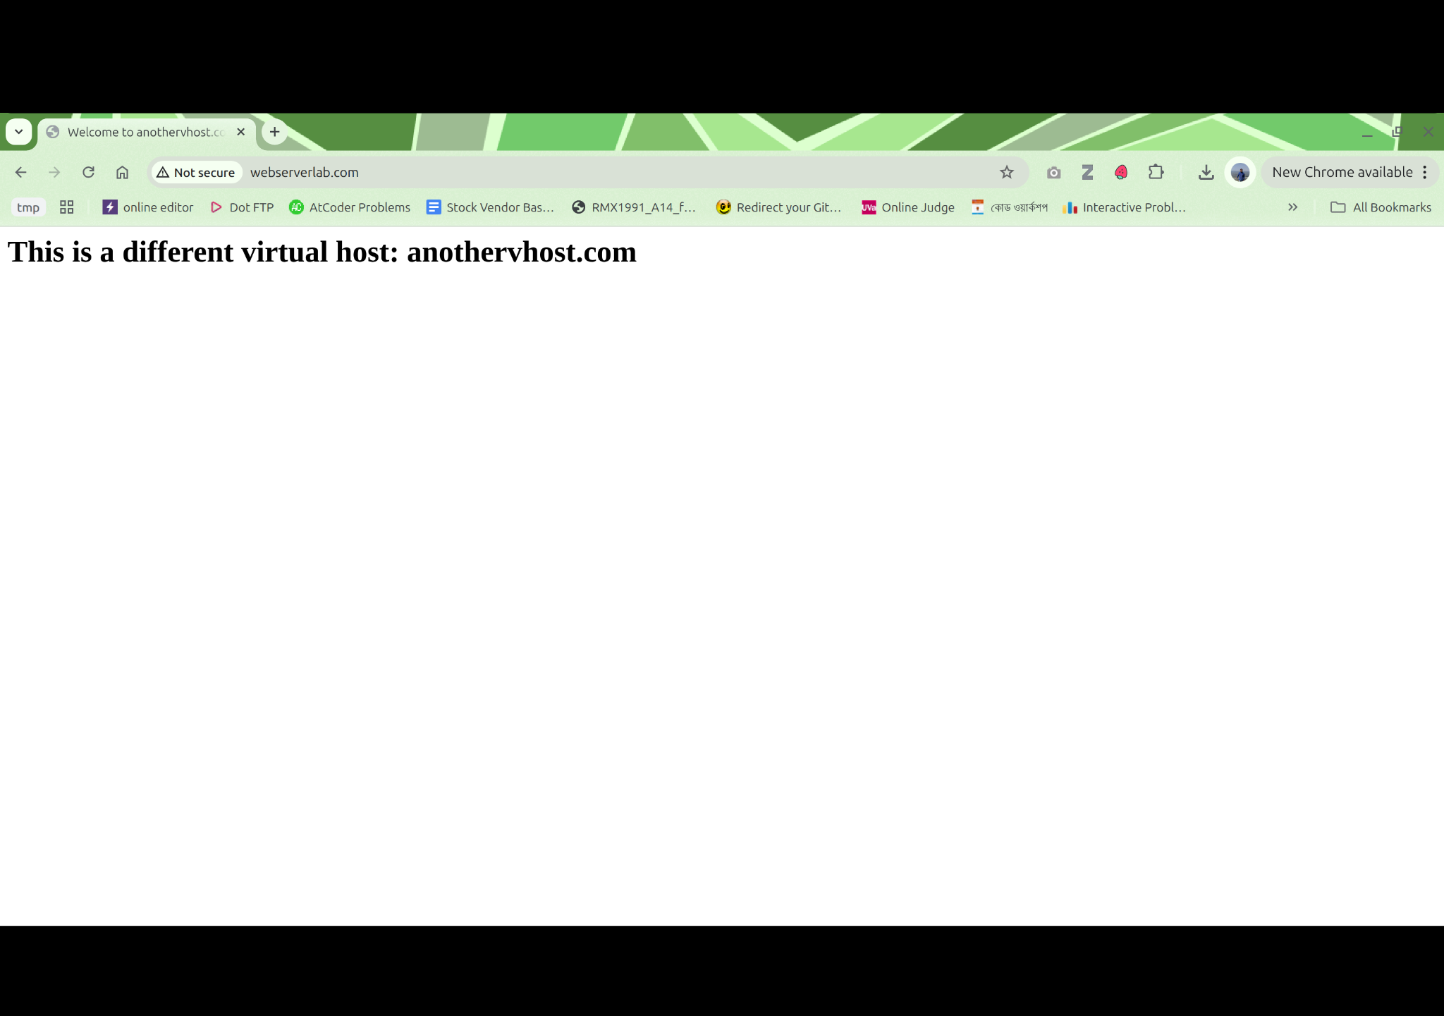

## **Checkpoint-4: Creating a Second Virtual Host (anothervhost.com)**

### **Step 4.1 – Create Directory Structure and Provide Privilege for Ownership and Execution**

| sudo mkdir -p /var/www/anothervhost.com/html |
| --- |

| sudo chown -R $USER:$USER /var/www/anothervhost.com/html |
| --- |

| sudo chmod -R 755 /var/www/anothervhost.com |
| --- |

### **Step 4.2 – Create HTML Content**

| nano /var/www/anothervhost.com/html/index.html |
| --- |

| <html>  <head><title>Welcome to AnotherVHost!</title></head>  <body><h1>This is another virtual host site.</h1></body> </html> |
| --- |

### **Step 4.3 – Create Configuration File**

| sudo nano /etc/apache2/sites-available/anothervhost.com.conf |
| --- |

| <VirtualHost *:80>  ServerAdmin admin@anothervhost.com  ServerName anothervhost.com  ServerAlias www.anothervhost.com  DocumentRoot /var/www/anothervhost.com/html   ErrorLog ${APACHE_LOG_DIR}/another_error.log  CustomLog ${APACHE_LOG_DIR}/another_access.log combined </VirtualHost> |
| --- |

### **Step 4.4 – Enable Site and Restart Apache**

| sudo a2ensite anothervhost.com.conf |
| --- |

| sudo apache2ctl configtest |
| --- |

| sudo systemctl restart apache2 |
| --- |

### **Step 4.5 – Update Hosts File**

| 127.0.0.1 localhost webserverlab.com example.com anothervhost.com |
| --- |

### **Step 4.6 – Test Both Sites**

Visit:

http://example.com

http://anothervhost.com

Each should load its own distinct page.

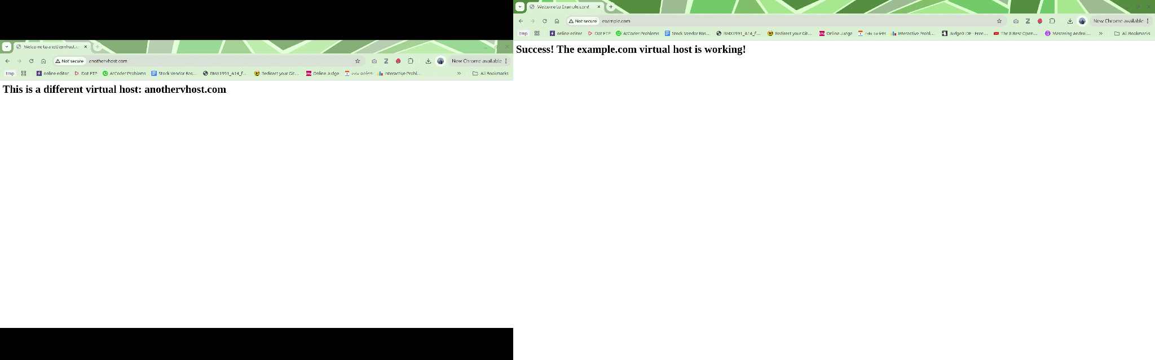

## **Checkpoint-5: Hosting Two Dynamic JavaScript-Based Websites**

### **Step 5.1 – Verify Existing Virtual Hosts**

Ensure both virtual hosts are already configured and working:

| sudo a2ensite example.com.conf |
| --- |

| sudo a2ensite anothervhost.com.conf |
| --- |

| sudo systemctl restart apache2 |
| --- |

Verify in /etc/hosts:

| 127.0.0.1 localhost webserverlab.com example.com anothervhost.com |
| --- |

### **Step 5.2 – Dynamic Website 1: example.com (Simple Calculator)**

#### **a. Create/Replace HTML file**

| nano /var/www/example.com/html/index.html |
| --- |

Paste the following:

| <!DOCTYPE html> <html>  <head>  <meta charset="utf-8" />  <title>Example.com - Simple Calculator</title>  </head>  <body>  <h1>Simple Addition Calculator</h1>  <form id="calcForm">  <label>Number 1:  <input type="number" id="num1" required />  </label><br /><br />  <label>Number 2:  <input type="number" id="num2" required />  </label><br /><br />  <button type="submit">Add</button>  </form>  <h2 id="result"></h2>   <script>  const form = document.getElementById("calcForm");  const result = document.getElementById("result");  form.addEventListener("submit", function (e) {  e.preventDefault();  const a = parseFloat(document.getElementById("num1").value);  const b = parseFloat(document.getElementById("num2").value);  if (isNaN(a) || isNaN(b)) {  result.textContent = "Please enter valid numbers.";  } else {  result.textContent = "Result: " + (a + b);  }  });  </script>  </body> </html> |
| --- |

#### **b. Test in Browser**

Visit:

http://example.com

Enter two numbers and press **Add**.  
The result should appear dynamically.

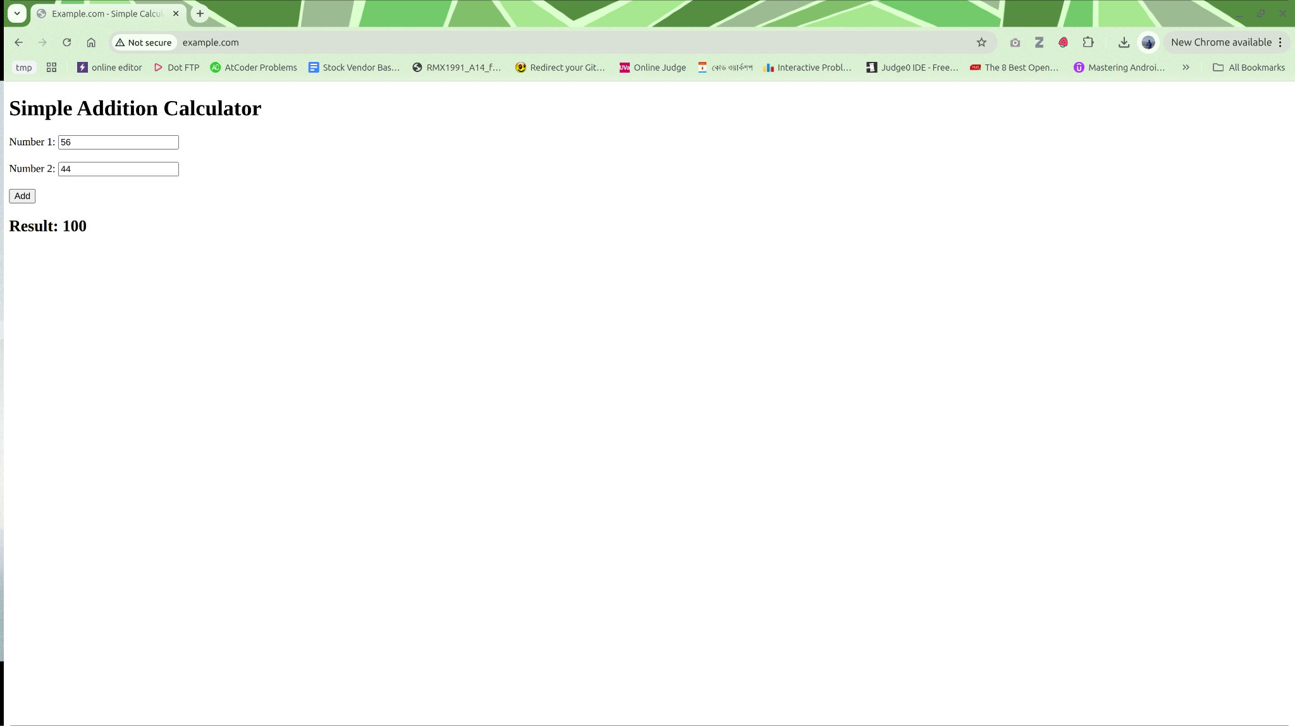

### **Step 5.3 – Dynamic Website 2: anothervhost.com (Grade Calculator)**

#### **a. Create/Replace HTML file**

| nano /var/www/anothervhost.com/html/index.html |
| --- |

Paste:

| <!DOCTYPE html> <html>  <head>  <meta charset="utf-8" />  <title>Anothervhost.com - Grade Calculator</title>  </head>  <body>  <h1>Grade Percentage Calculator</h1>  <form id="gradeForm">  <label>Quiz (out of 20): <input type="number" id="quiz" required /></label><br /><br />  <label>Midterm (out of 30): <input type="number" id="midterm" required /></label><br /><br />  <label>Final (out of 50): <input type="number" id="final" required /></label><br /><br />  <button type="submit">Calculate Total & Grade</button>  </form>  <h2 id="gradeResult"></h2>   <script>  const form = document.getElementById("gradeForm");  const output = document.getElementById("gradeResult");  form.addEventListener("submit", function (e) {  e.preventDefault();  const quiz = parseFloat(document.getElementById("quiz").value);  const mid = parseFloat(document.getElementById("midterm").value);  const fin = parseFloat(document.getElementById("final").value);  if (isNaN(quiz) || isNaN(mid) || isNaN(fin)) {  output.textContent = "Please enter all scores.";  return;  }  const total = quiz + mid + fin;  let grade;  if (total >= 80) grade = "A+";  else if (total >= 70) grade = "A";  else if (total >= 60) grade = "B";  else if (total >= 50) grade = "C";  else grade = "F";  output.textContent = "Total: " + total + "/100, Grade: " + grade;  });  </script>  </body> </html> |
| --- |

#### **b. Test in Browser**

Visit:

http://anothervhost.com

Input quiz, midterm, and final marks → click **Calculate** → total and grade appear instantly.

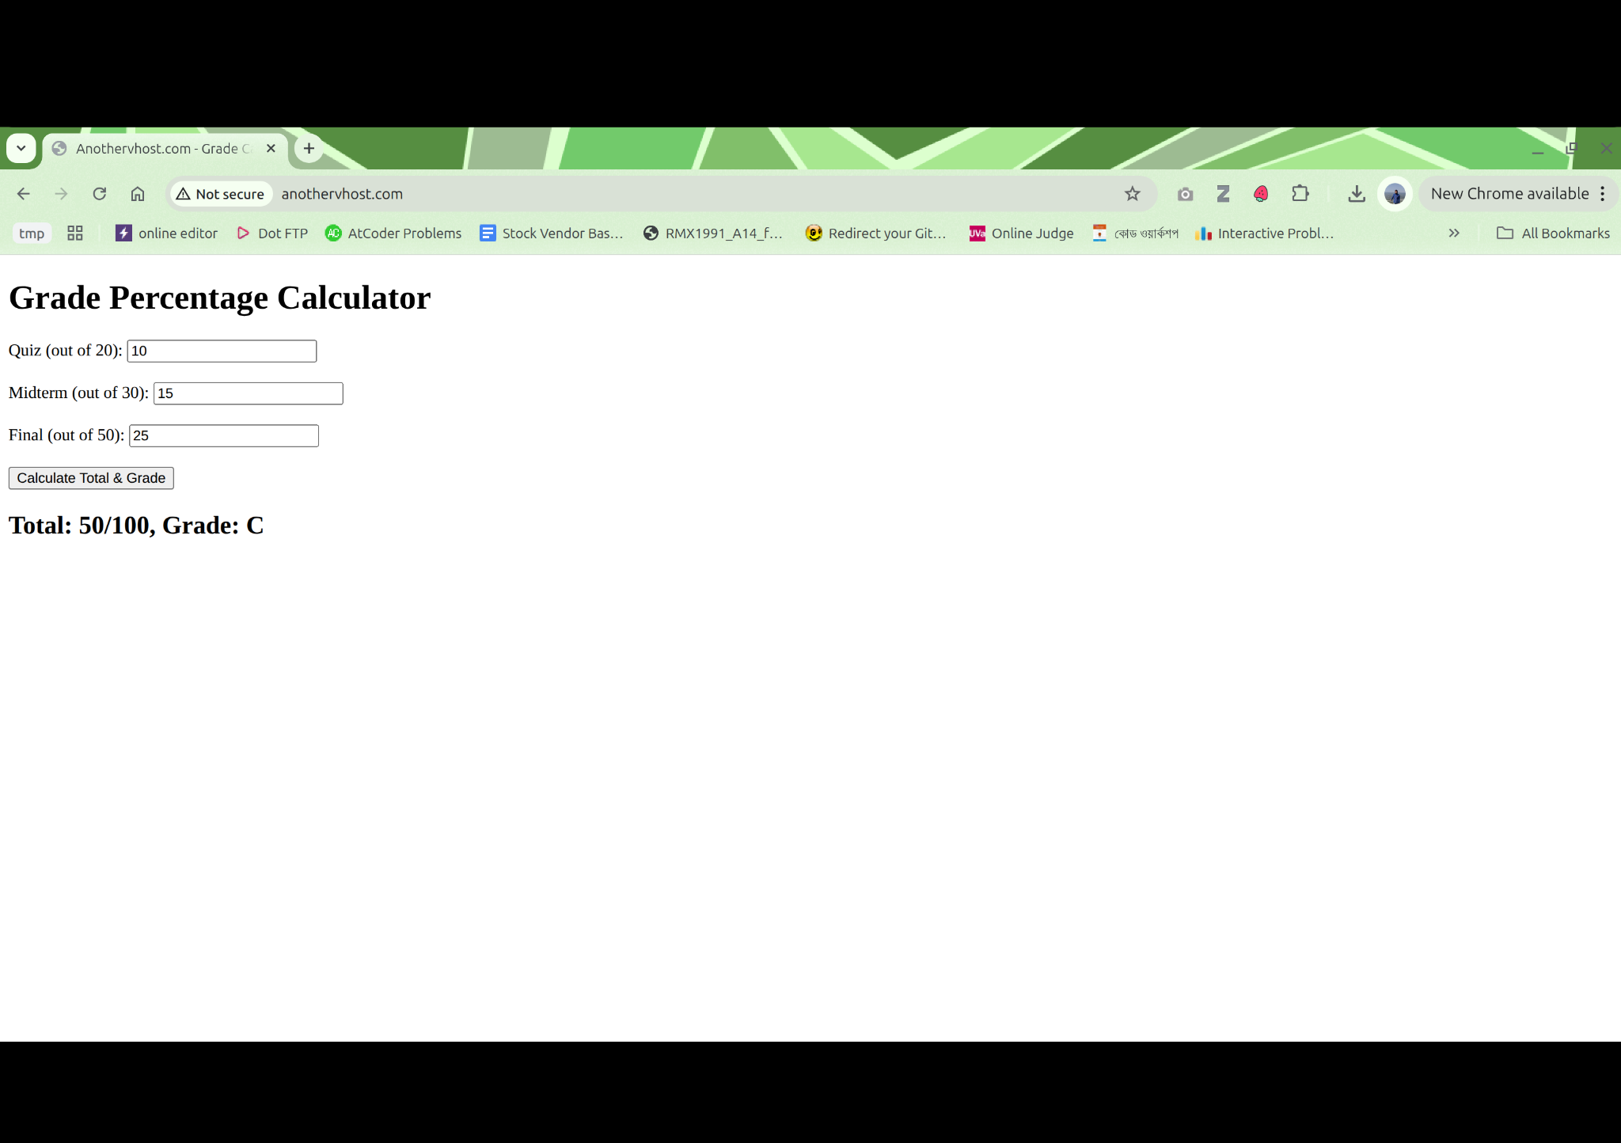

### **Step 5.4 – Validation**

Both sites work independently and dynamically:

| **Virtual Host** | **Functionality** | **Dynamic Feature** |
| --- | --- | --- |
| example.com | Addition Calculator | JavaScript form + instant result |
| anothervhost.com | Grade Calculator | JavaScript form + instant grade output |

## **Observations**

* Apache successfully serves multiple **dynamic** front-end websites.
* No server-side language was used; all logic handled via **client-side JavaScript**.
* Each virtual host uses its own document root and configuration file.
* Demonstrates the concept of **hosting multiple applications/domains** on a single local machine.